Jenkins Tas 04

- Setup Jenkins CICD pipeline using freestyle job using Docker containers using below code. https://github.com/betawins/hiring-app.git
Stages:
Git Clone: To Download the source code.
Stage 1: Git Clone via Jenkins
- Login to Jenkins server.
Create a Freestyle Project.
- Configure Git SCM with repository:
https://github.com/betawins/hiring-app.git
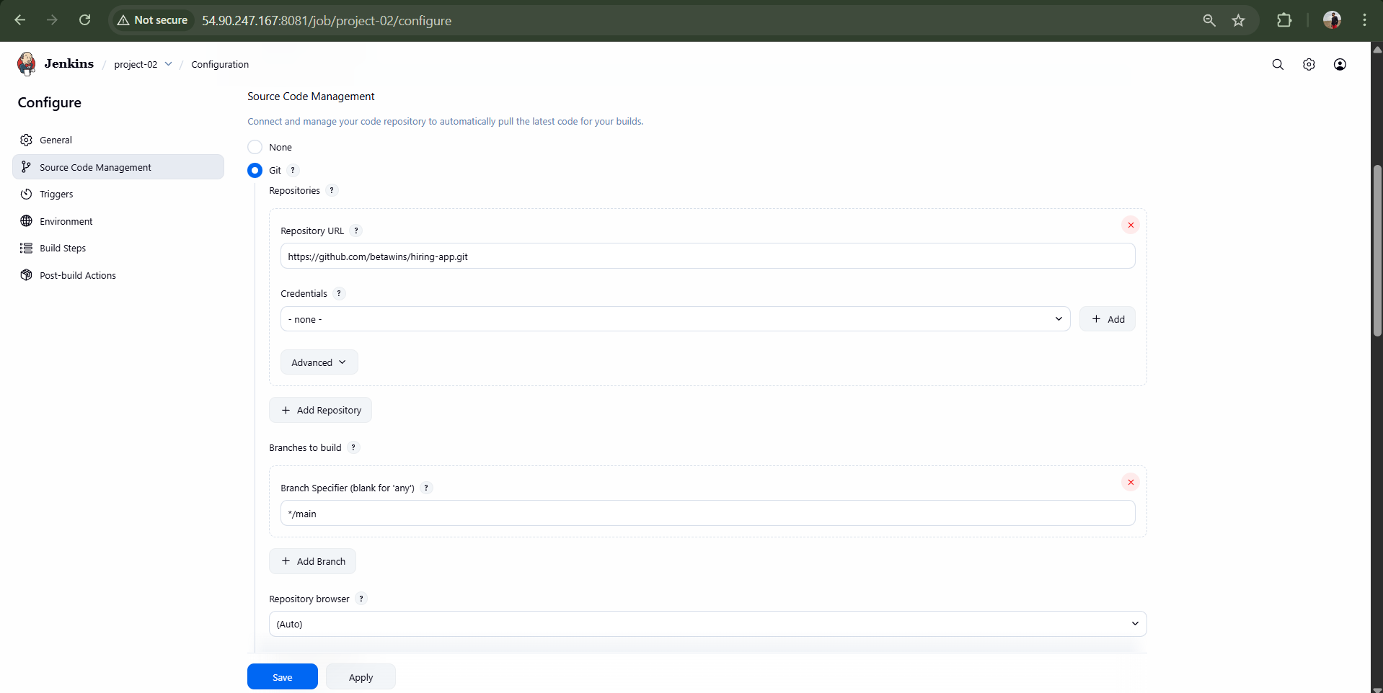
- Save and click Build Now.
Result: Repository cloned successfully.
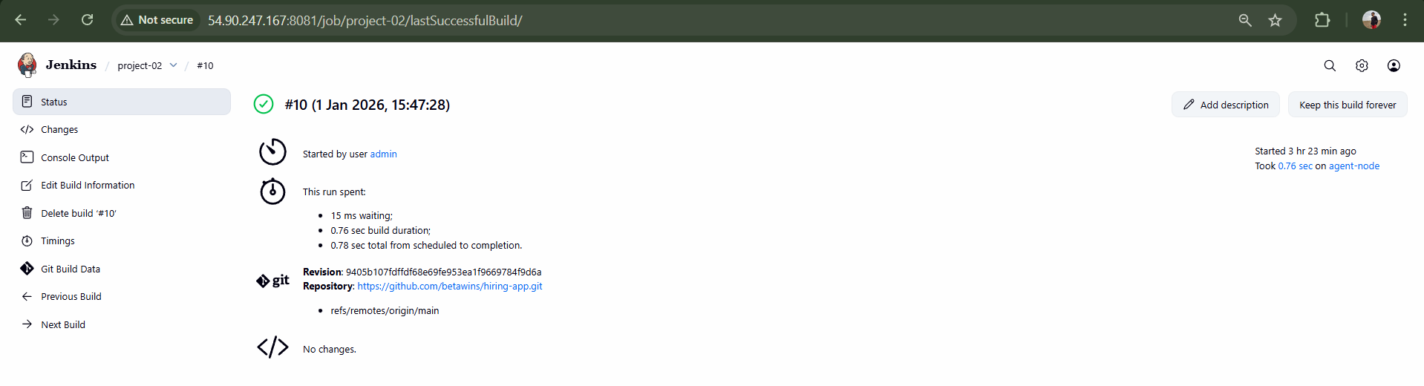

SonarQube Integration: To check for the quality of the code.
Launch a new EC2 instance.
Instance type: t2.large Select volume: 20 gb ebs volume
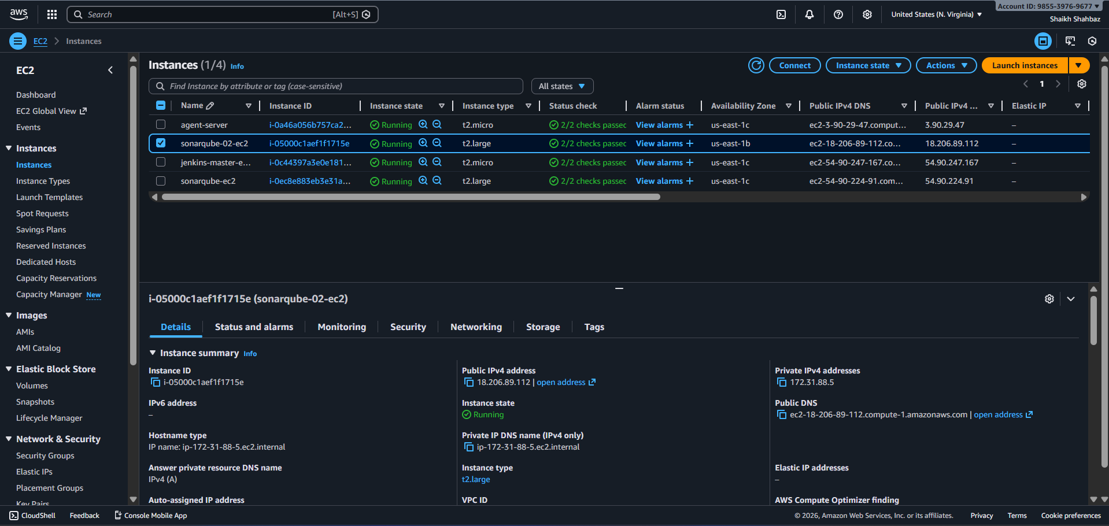
- Install Docker:
sudo yum install docker -y
sudo systemctl start docker
sudo systemctl enable docker
sudo systemctl status docker
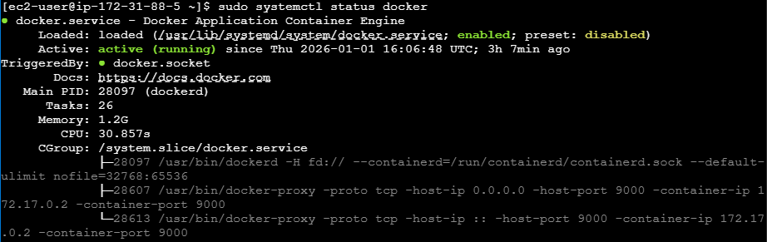
- Pull SonarQube image:
sudo docker pull sonarqube
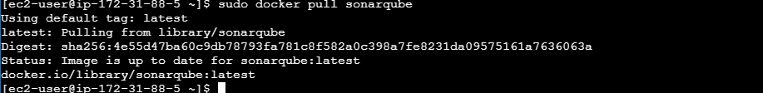

- Run SonarQube container:
docker run -d --name sonarqube -p 9000:9000 sonarqube:lts

- Access SonarQube:
http://<Public-IP>:9000
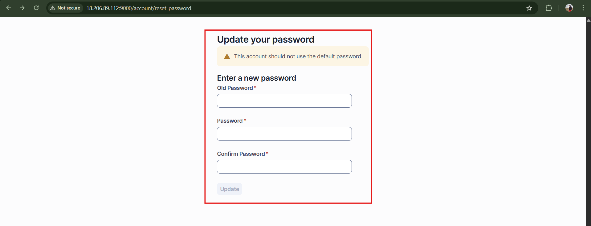
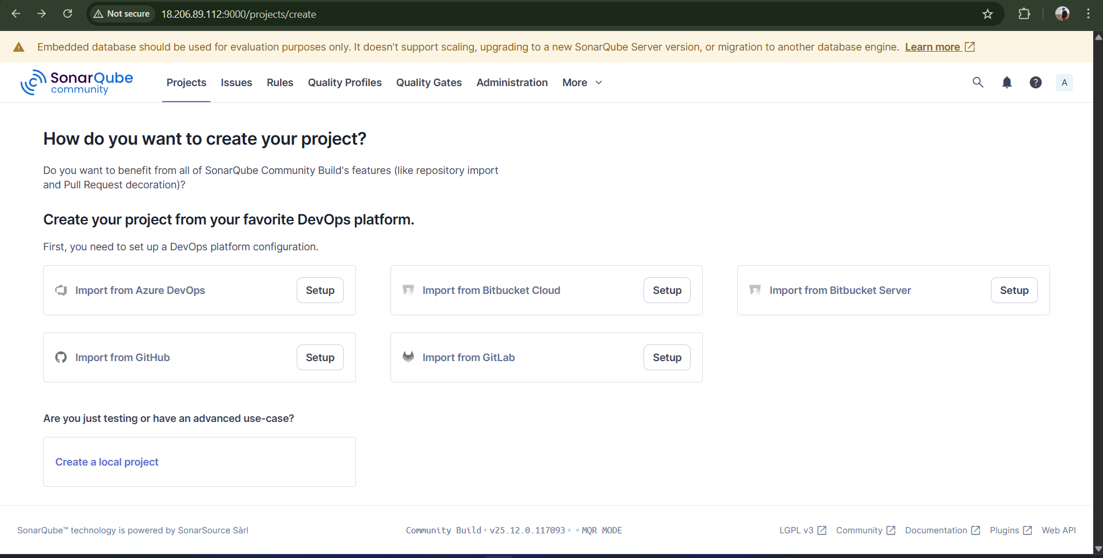
- Generate SonarQube token.
Goto sonarqube my account security tab Generate tokens
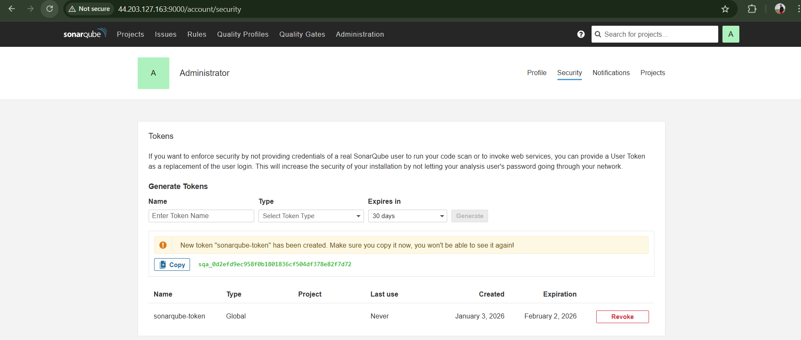
- In Jenkins:
  - Install SonarQube Scanner Plugin
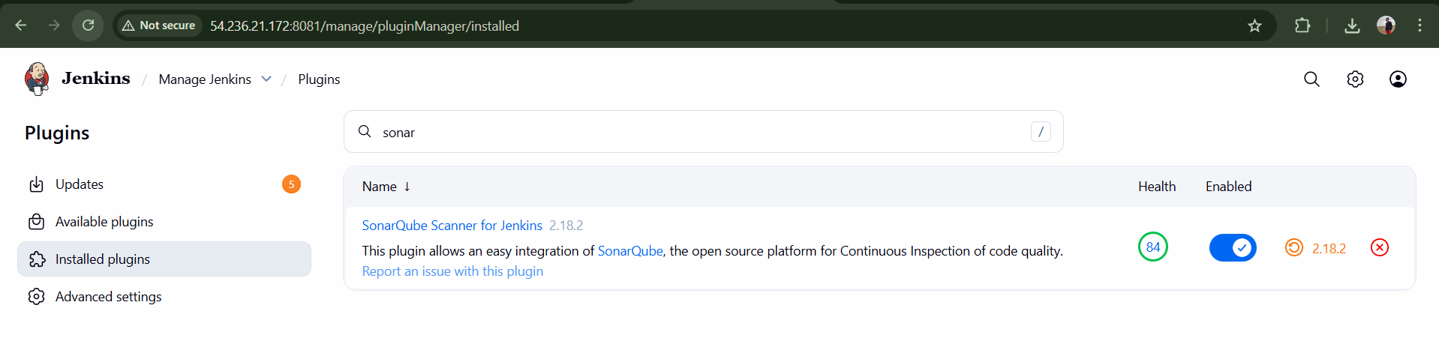
  - Configure SonarQube server details
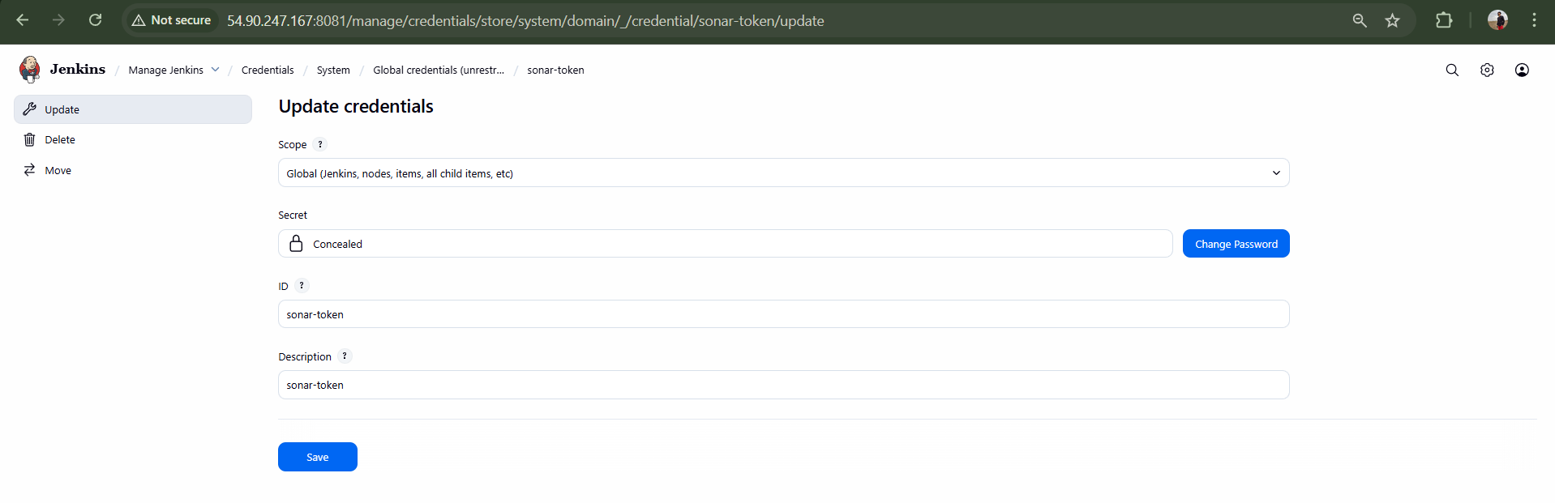
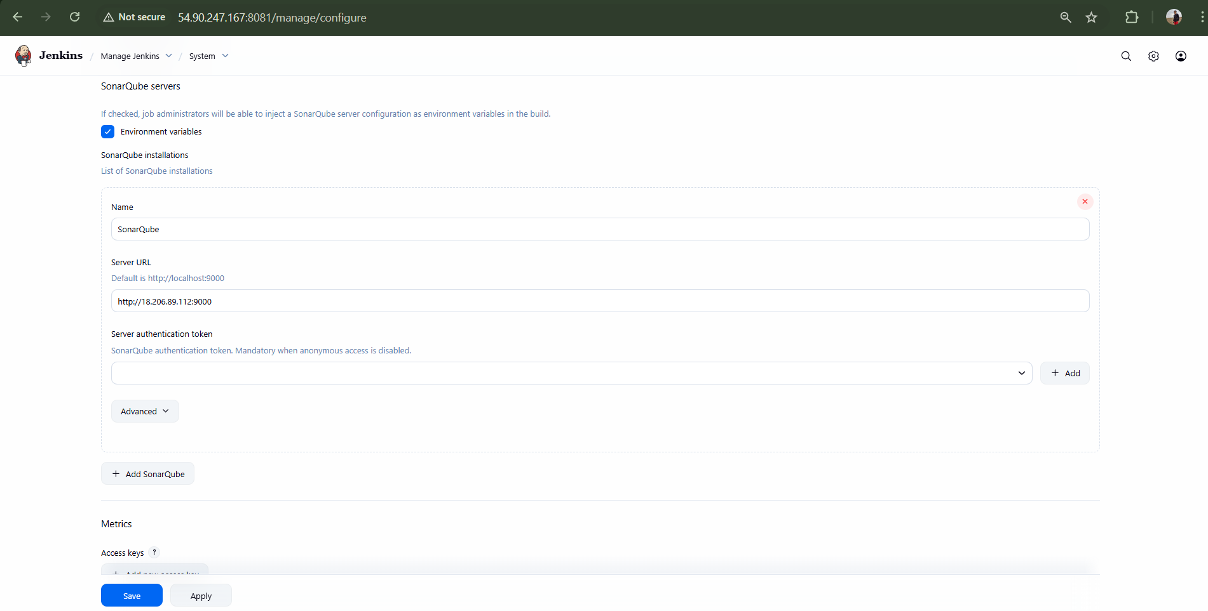
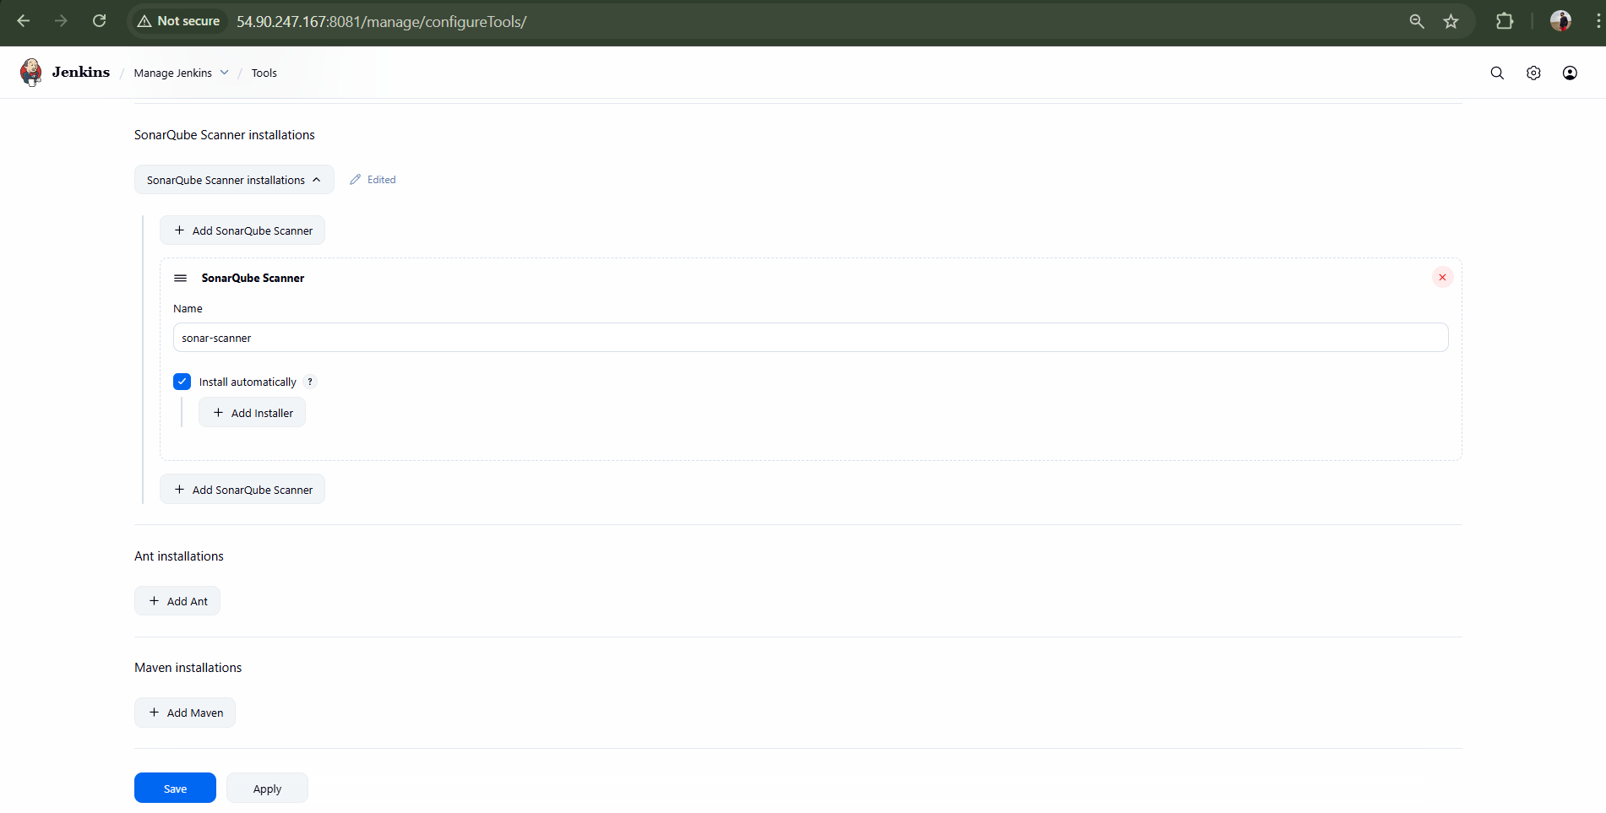

- Add SonarQube scanner build step and execute build.
Result: Code is successfully scanned and pushed to SonarQube dashboard.

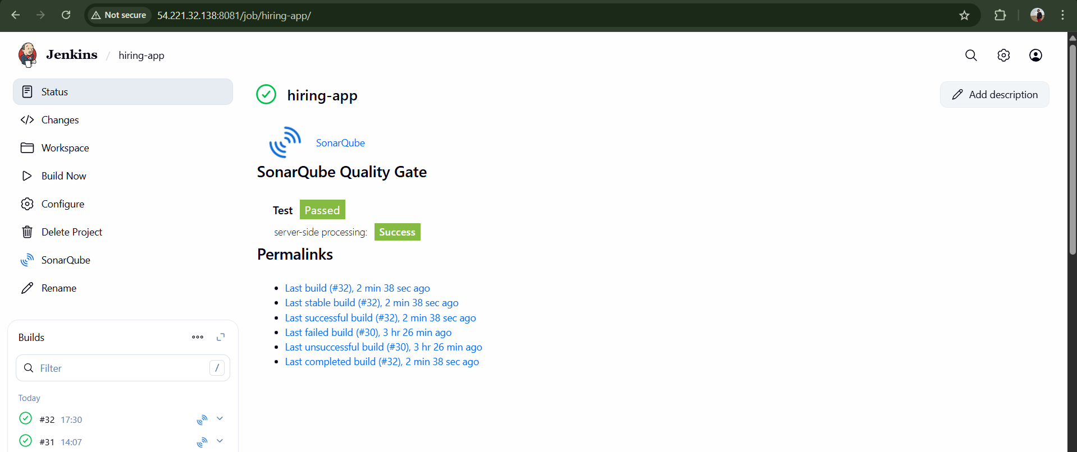
Validation : After adding sonar analysis to the highring-app build then we can see that sonarqube is checking the code quality that we can see below
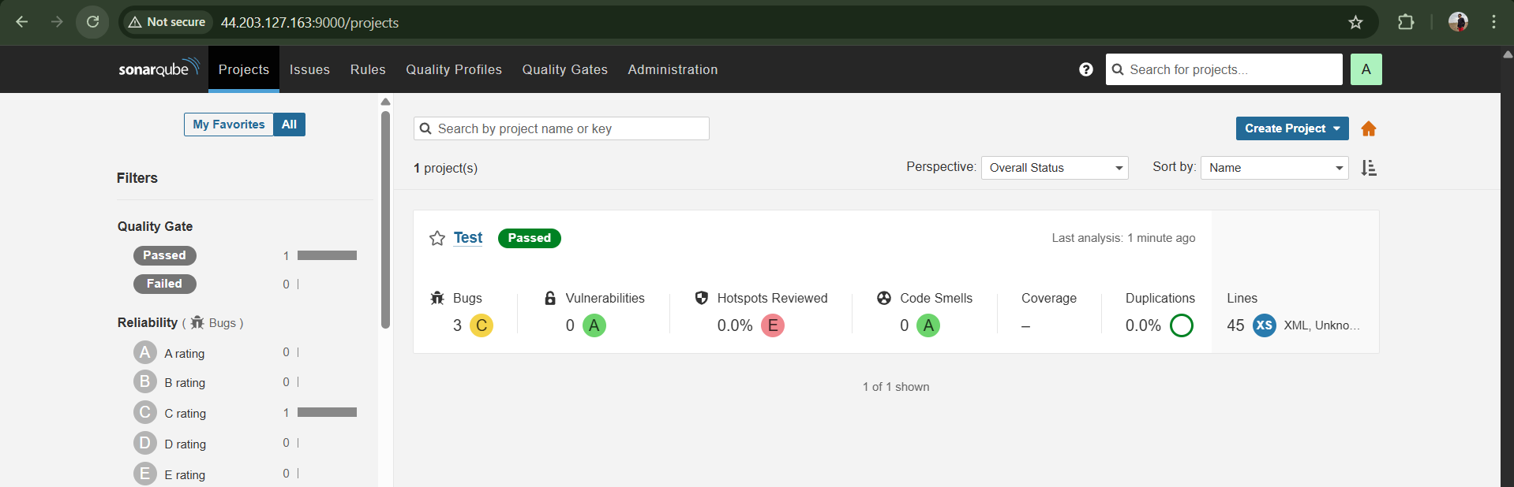

Maven Compilation : Compile the source code and create a package.

Download apache maven in Jenkins master ec2
cd /opt
wget https://dlcdn.apache.org/maven/maven-3/3.9.12/binaries/apache-maven-3.9.12-bin.tar.gz
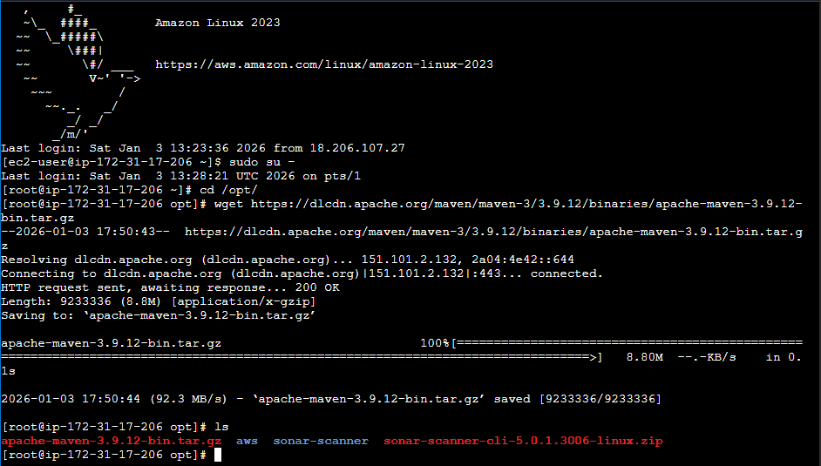
To extract this downloaded file use command
tar xvf apache-maven-3.9.12-bin.tar.gz
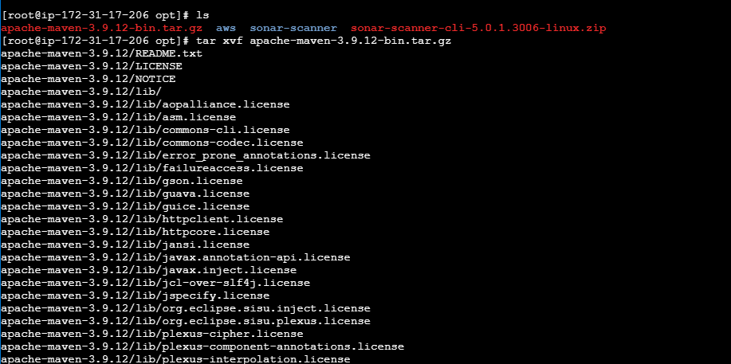
To get inside the extracted maven directory
cd apache-maven-3.9.12
cd bin
pwd
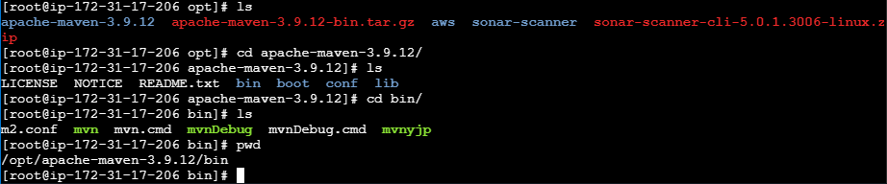
Now we need to pass this path to global variable in order to use mvn –version at any location in cli
For that change directory to home directory
cd
vi .bash_profiles .bash_profile : contains global variables
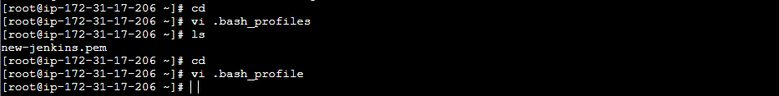
MVN_HOME=/opt/apache-maven-3.9.12/bin
PATH=$PATH:$HOME/bin:$MVN_HOME

export PATH
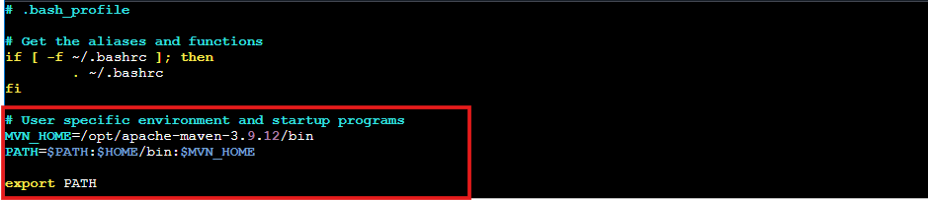
Now we need to restart the .bash_profile
source ~/.bash_profile
echo $MVN_HOME
mvn --version
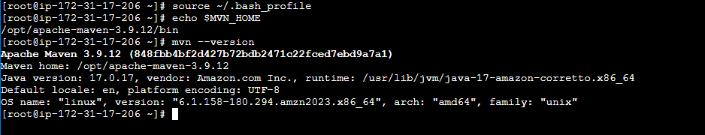
Now to configure maven path to Jenkins
Go to Jenkins UI tools maven /opt/apache-maven-3.9.12
Name : MVN_HOME
MAVEN_HOME PATH :/opt/apache-maven-3.9.12
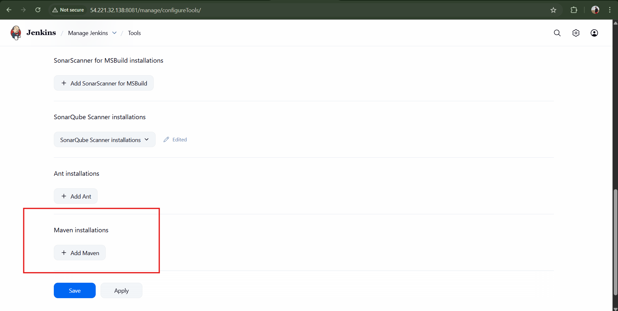
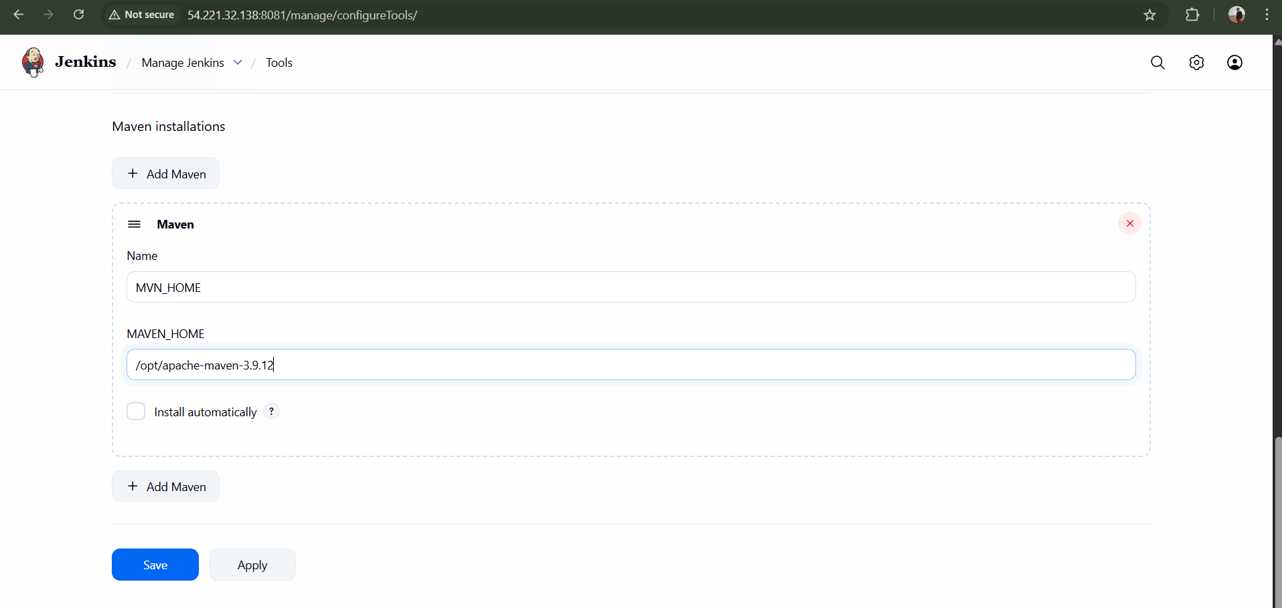
Now add Build step under hiring app configure
Add build step Select : Invoke top-level Maven targets
Goals : clean install
save
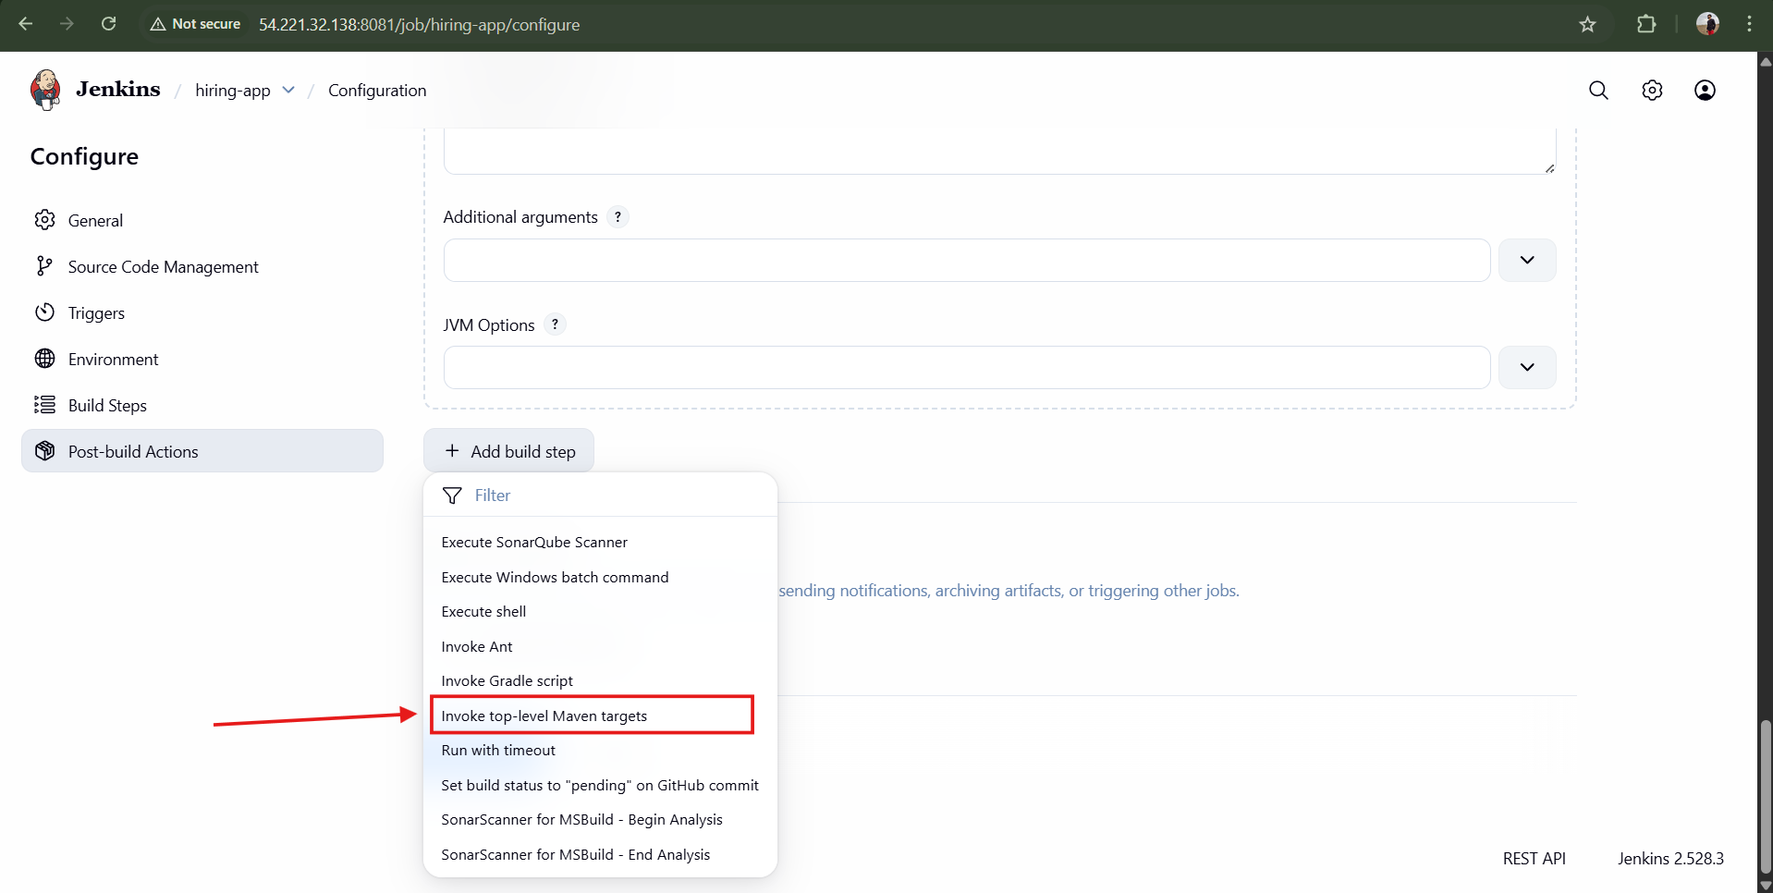
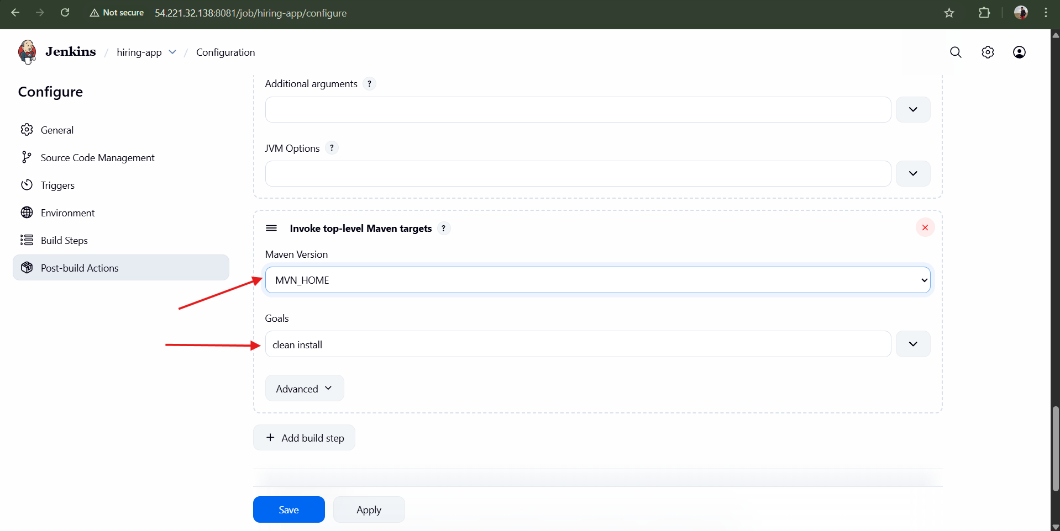
Now we have installed and configured Maven in Jenkins
Run the job hiring app Build now
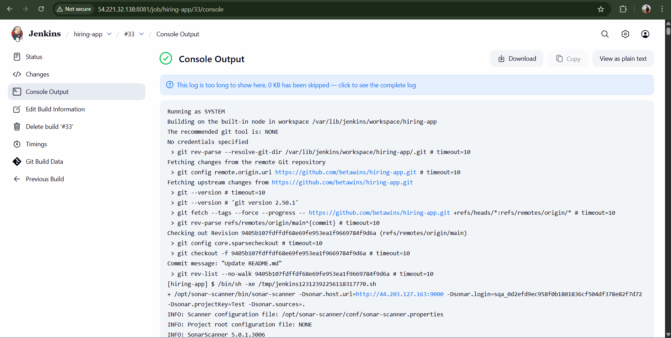
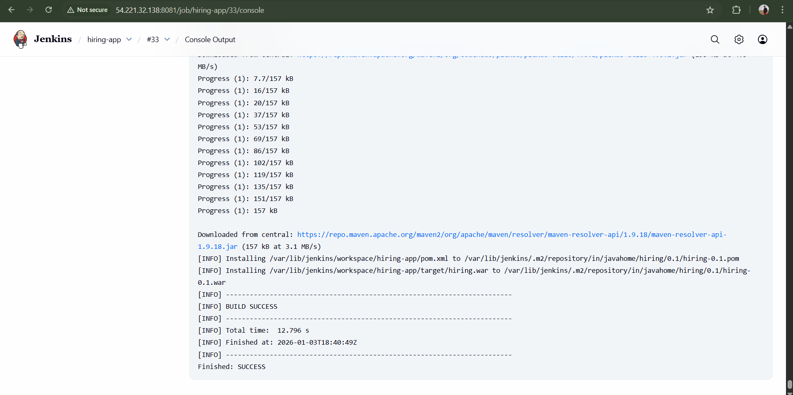
In Jenkins server run the below command to check <.war> file in <target directory>
Target directory is created when the maven compile is successfully executed
cd /var/lib/jenkins/workspace/hiring-app/target
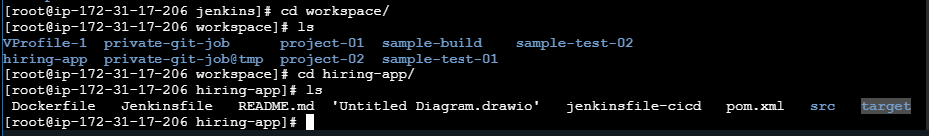
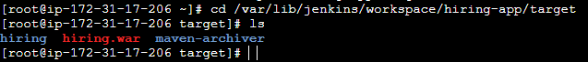

Now check for .m2 repository for any dependencies in Jenkins server
cd /var/lib/jenkins/.m2/repository
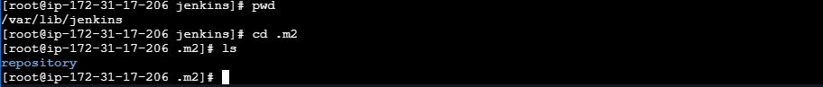
Dependencies related to maven is created in .m2 directory and these dependencies are stored in .m2/repository
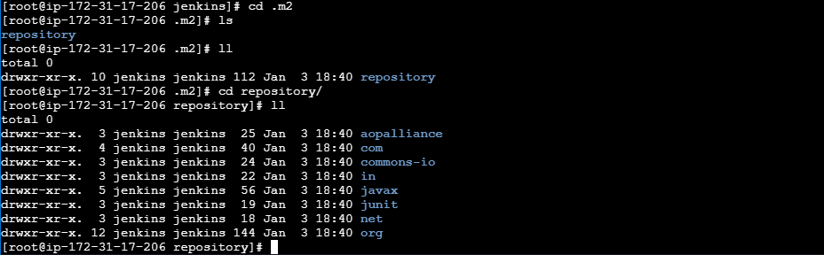

Nexus Artifactory: To store the artifacts in central location.
Create Nexus-ec2 with t2.large
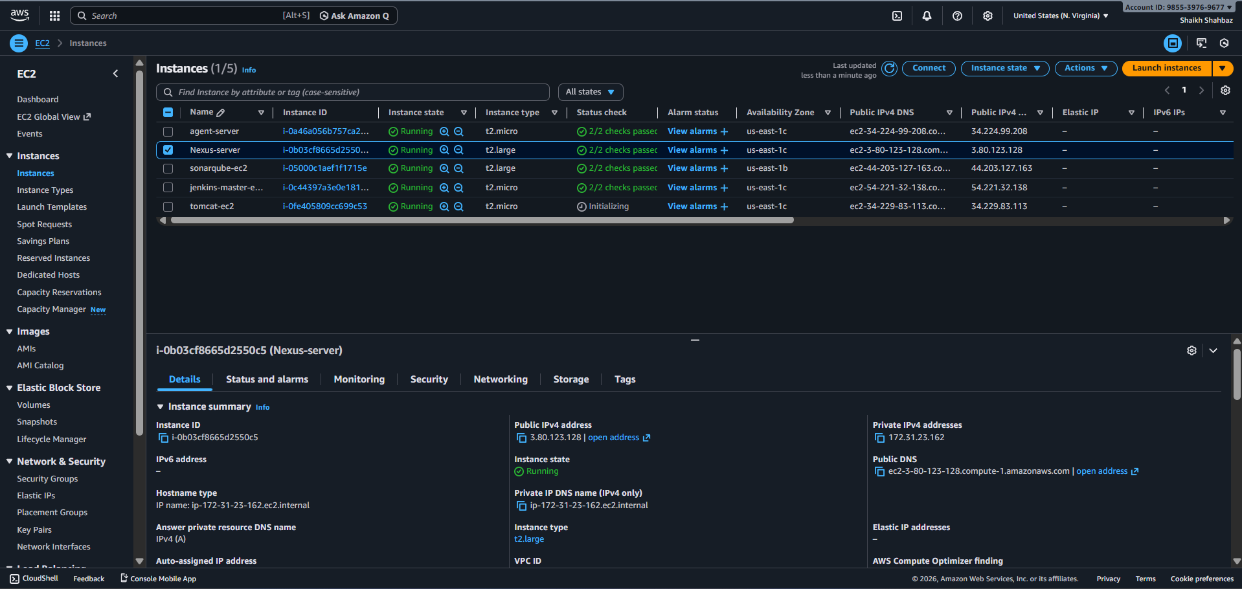
Install java yum install -y java-17-amazon-corretto
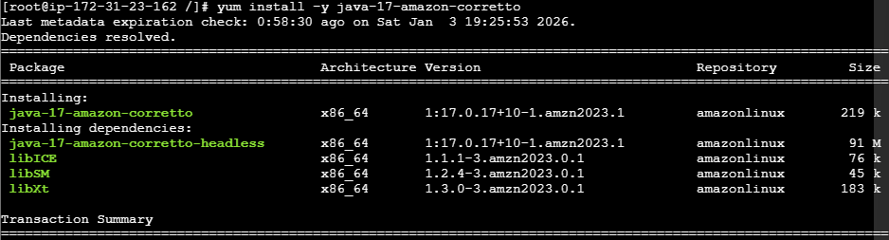
java -version
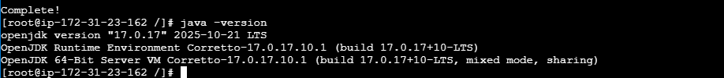
Now download nexus in nexus-ec2
cd /opt
wget https://download.sonatype.com/nexus/3/nexus-3.68.1-02-unix.tar.gz
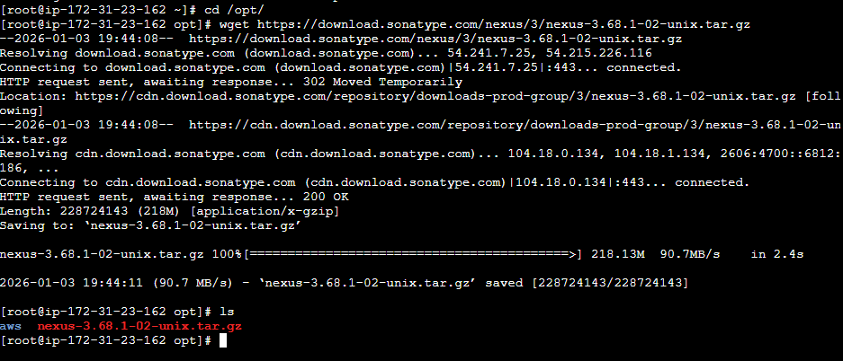
tar -zxvf nexus-3.68.1-02-unix.tar.gz
mv nexus-3.68.1-02 nexus
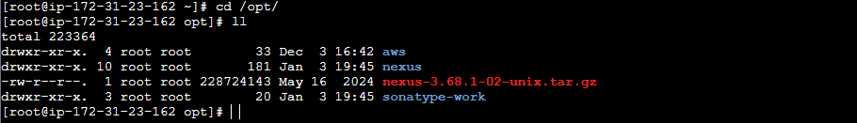
Nexus can not run as <root user>, so that we need to change the user from <root> to <nexus>
vi /opt/nexus/bin/nexus.rc file
Remove # and Add run_as_user=”nexus”
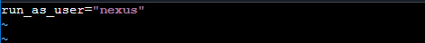
Now we need to add the user and change the ownership for <nexus user>
useradd nexus
chown -R nexus:nexus /opt/nexus /opt/sonatype-work
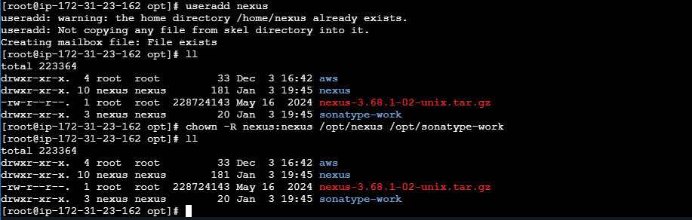
Now start Nexus
cd /opt/nexus/bin
./nexus start
./nexus status
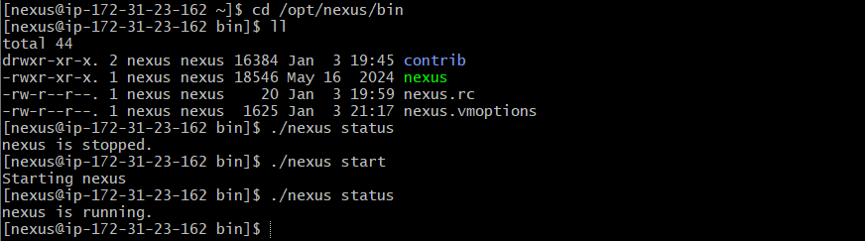
Once status is running, open in browser:
http://<EC2_PUBLIC_IP>:8081
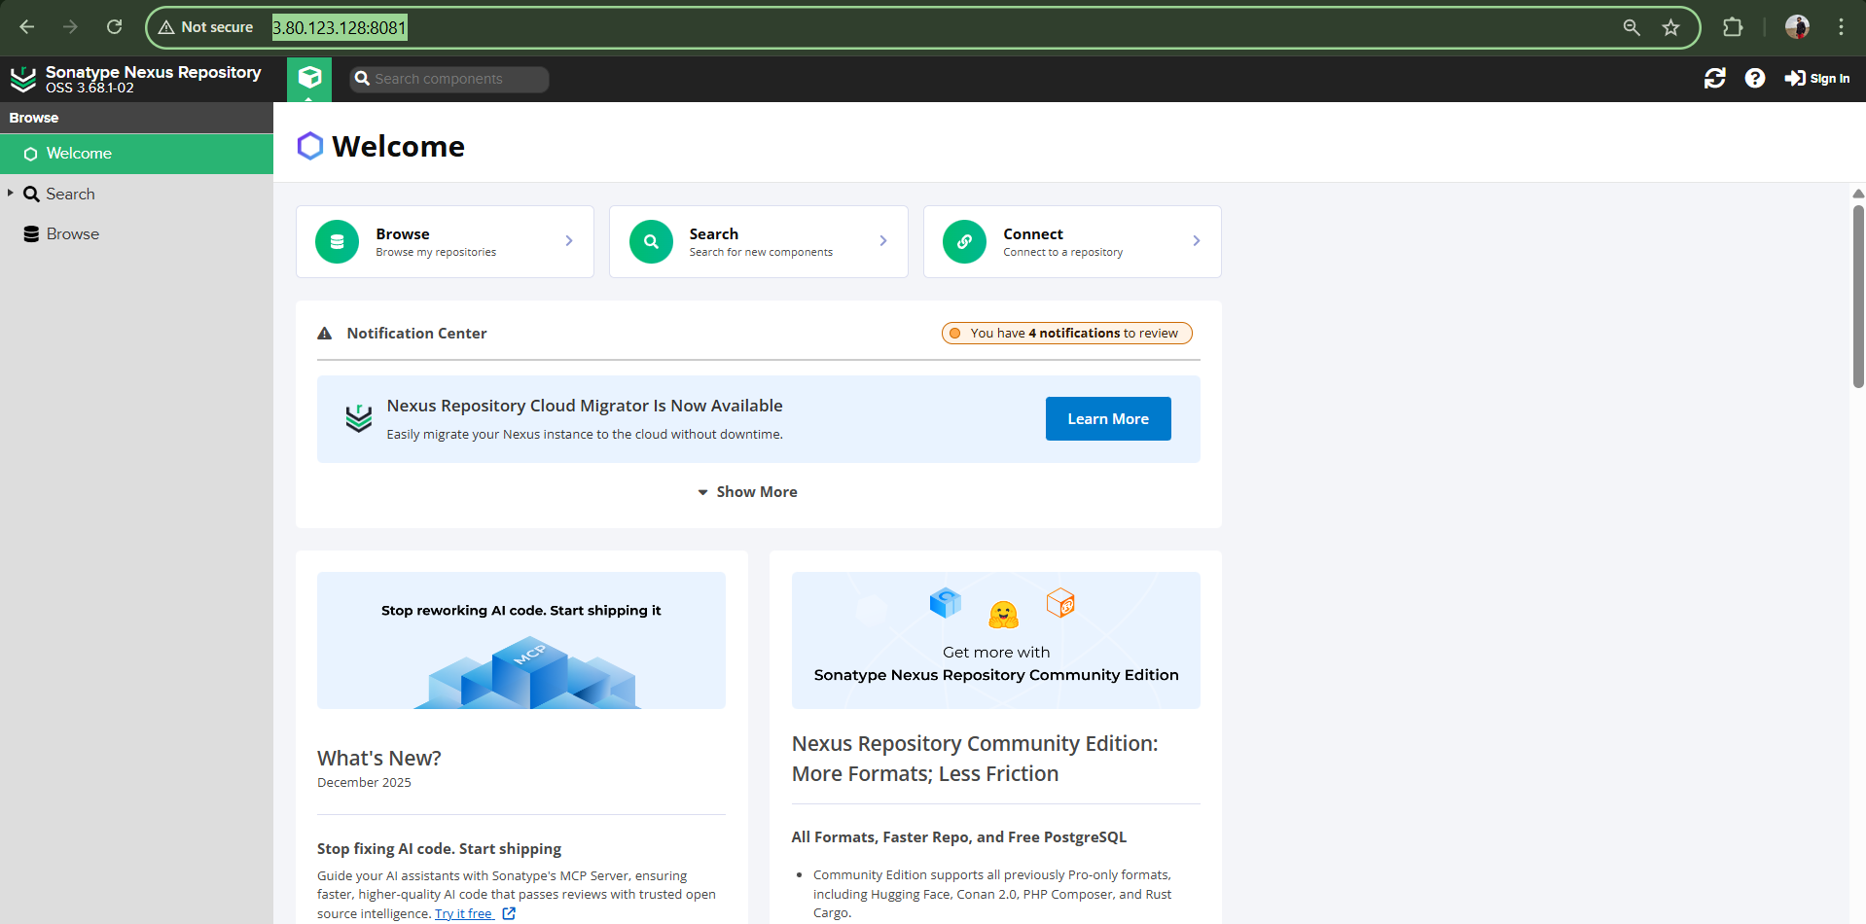
cat /opt/sonatype-work/nexus3/admin.password
Sign in : admin
Password : 6d1cf164-d765-49dc-9f87-aa4628dff2ae
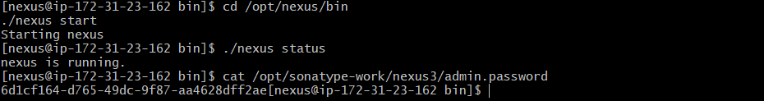
Copy this password and paste it while logging in to Nexus
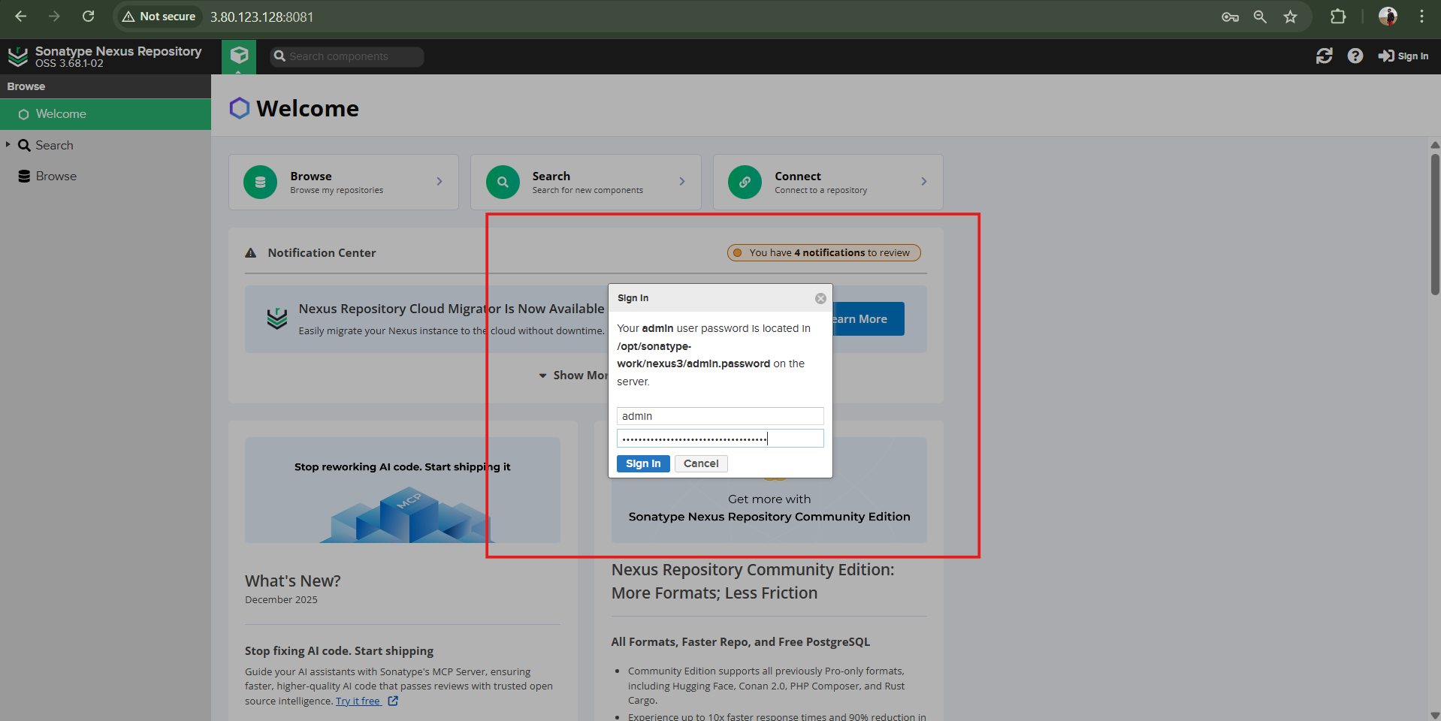
Choose / set new password
New password : nexus123
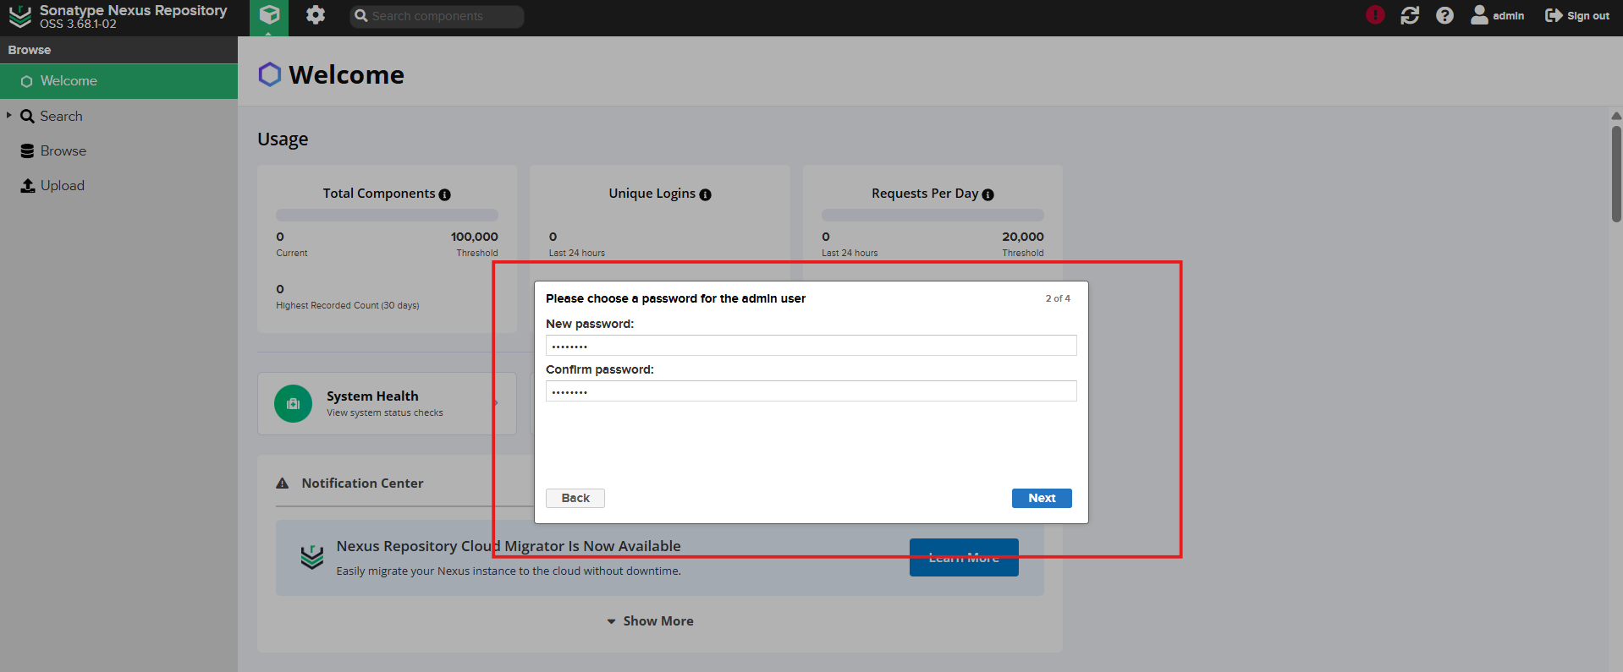
Now we need to integrate Jenkins with nexus in UI level
Install Nexus Plugin
Goto manage Jenkins plugins available plugins <Nexus Artifact Uploader> 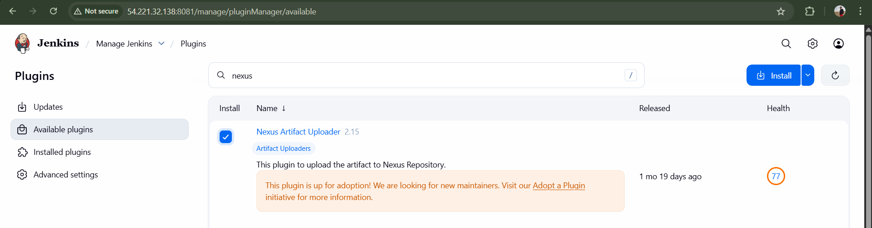
Now goto your job <hiring-app> configure build step <Nexus Artifact Uploader>
In git hub repo in pom.xml file we have some info group id and version though that we need to configure nexus in our job
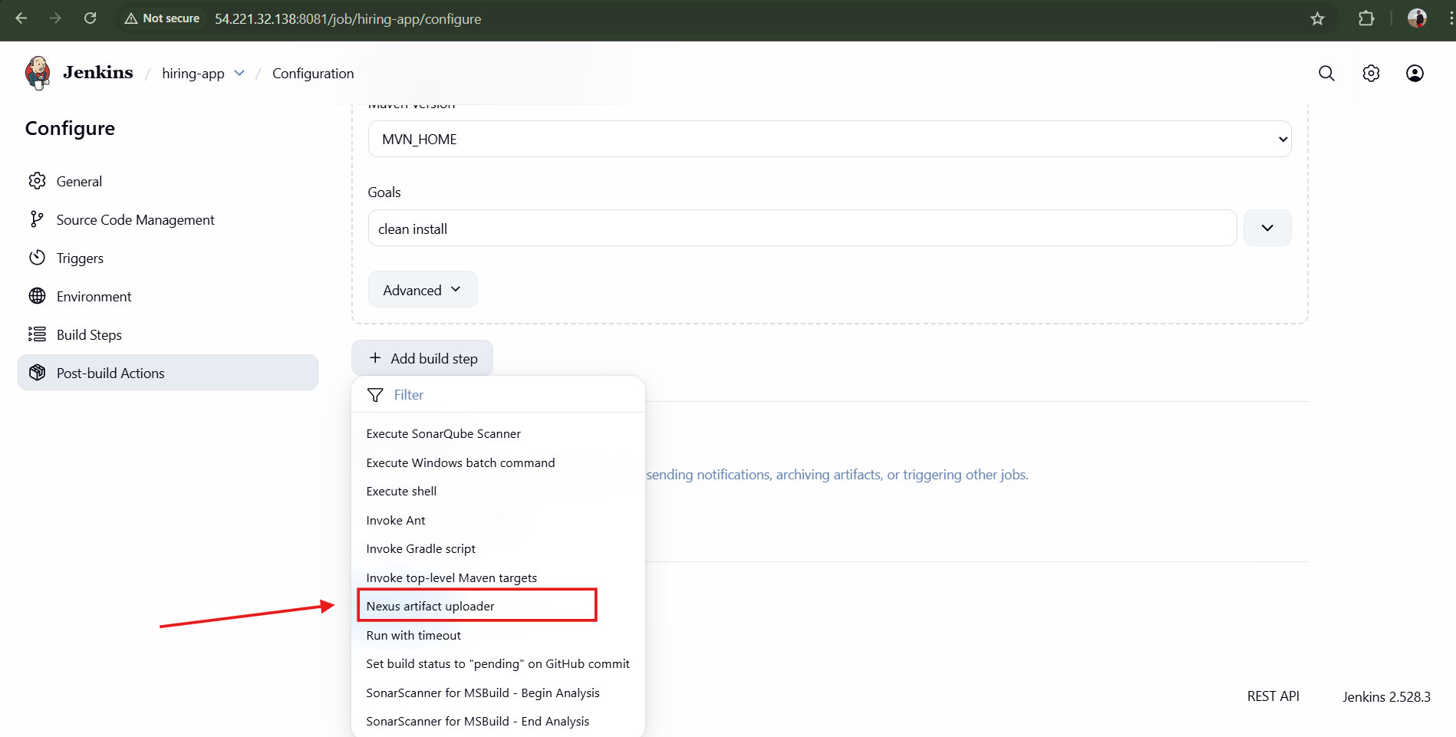
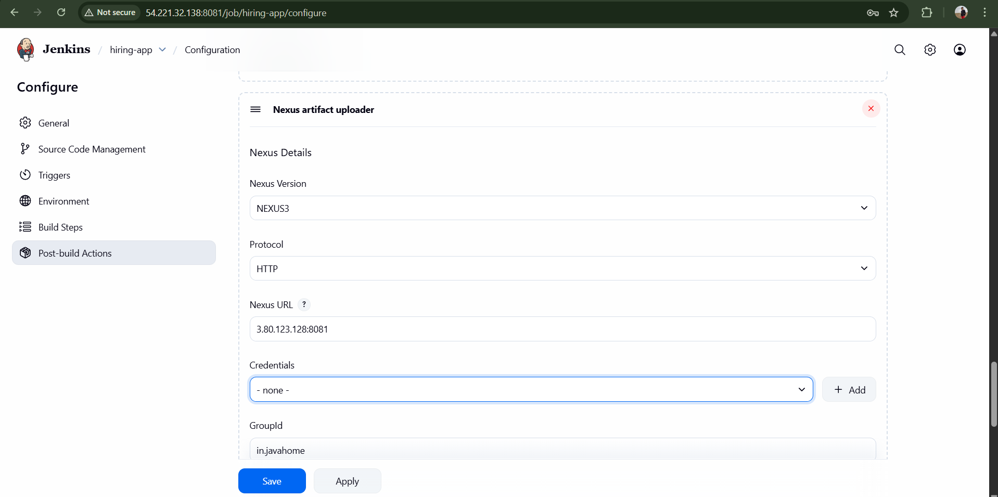
Now Create credentials for nexus and attach it here
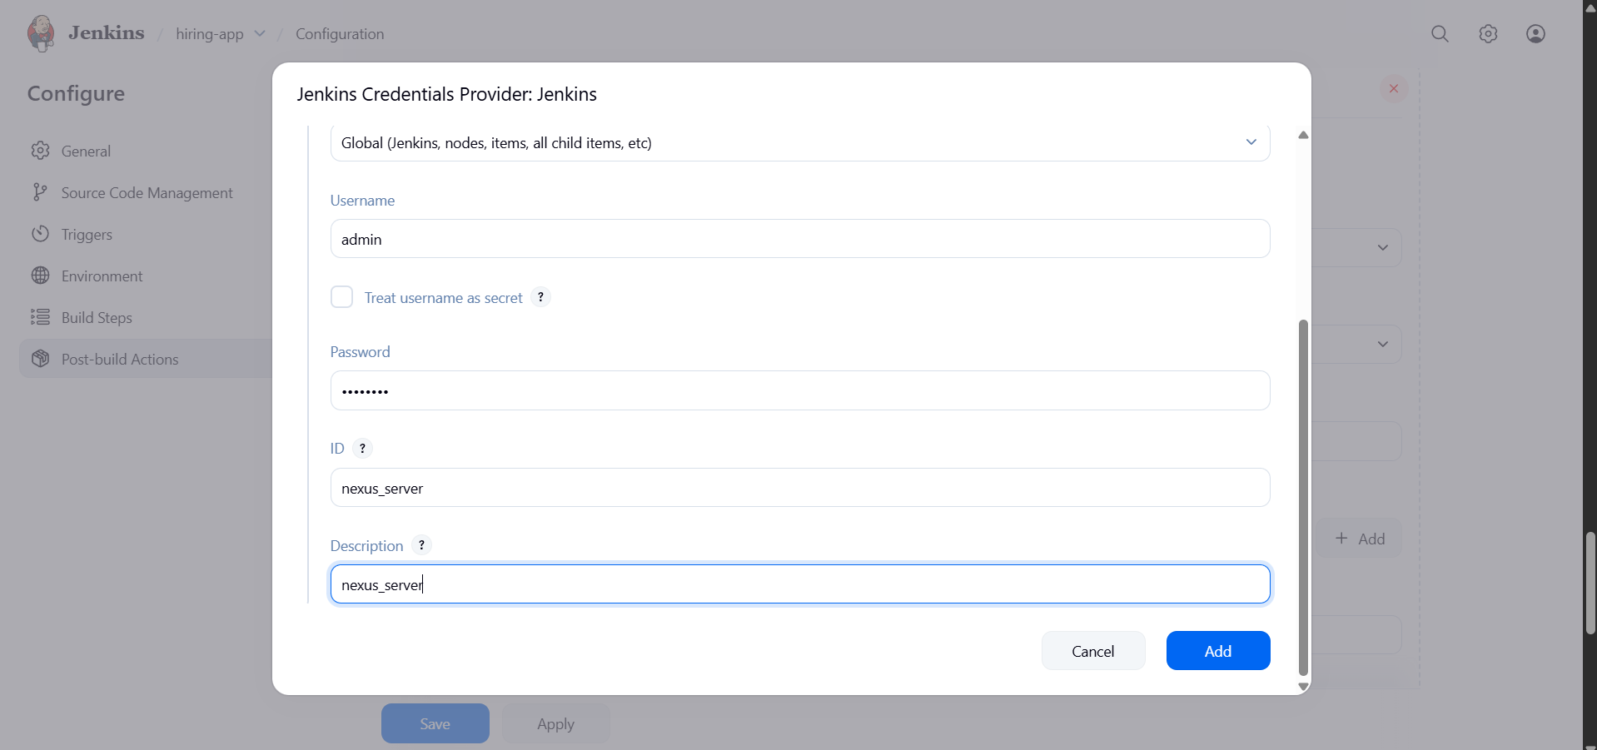
Now go to GitHub repo of hiring-app and open pom.xml file and add the required details to build steps of hiring-app job
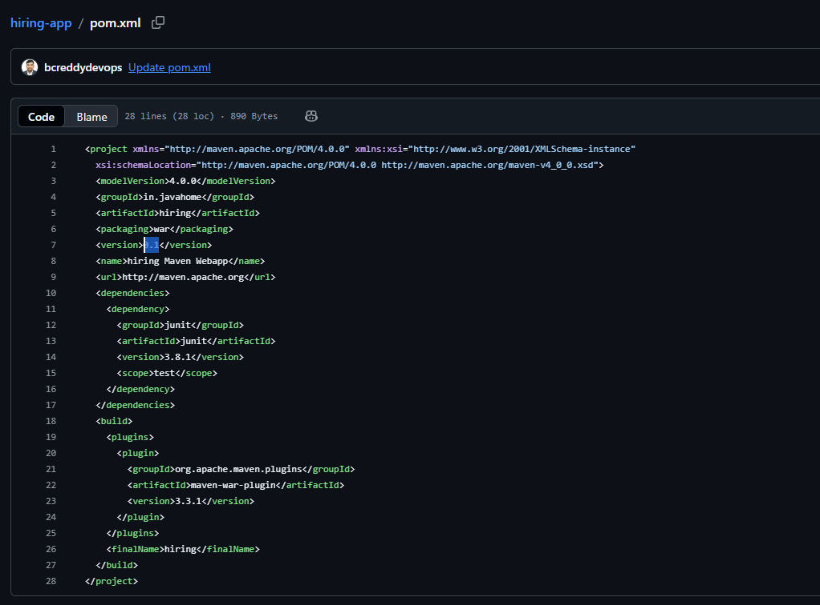

Go to Nexus GUI to create a repository to store the artifacts
Goto settings Repositories Create repository <maven2(hosted)>
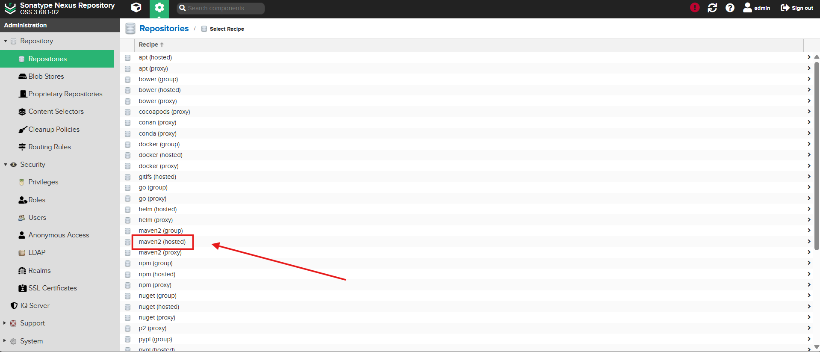
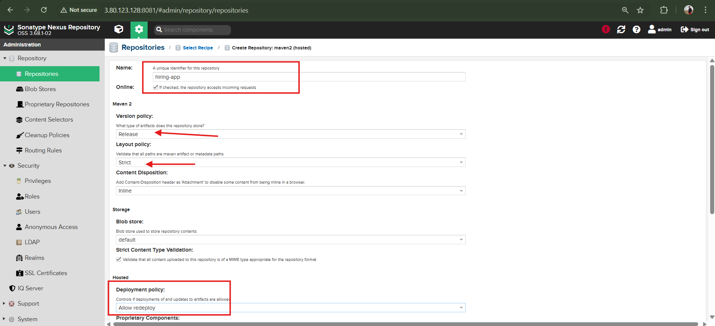
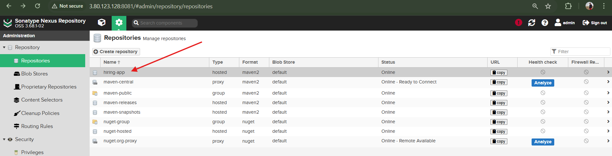

Jenkins hiring-app configuration Build steps
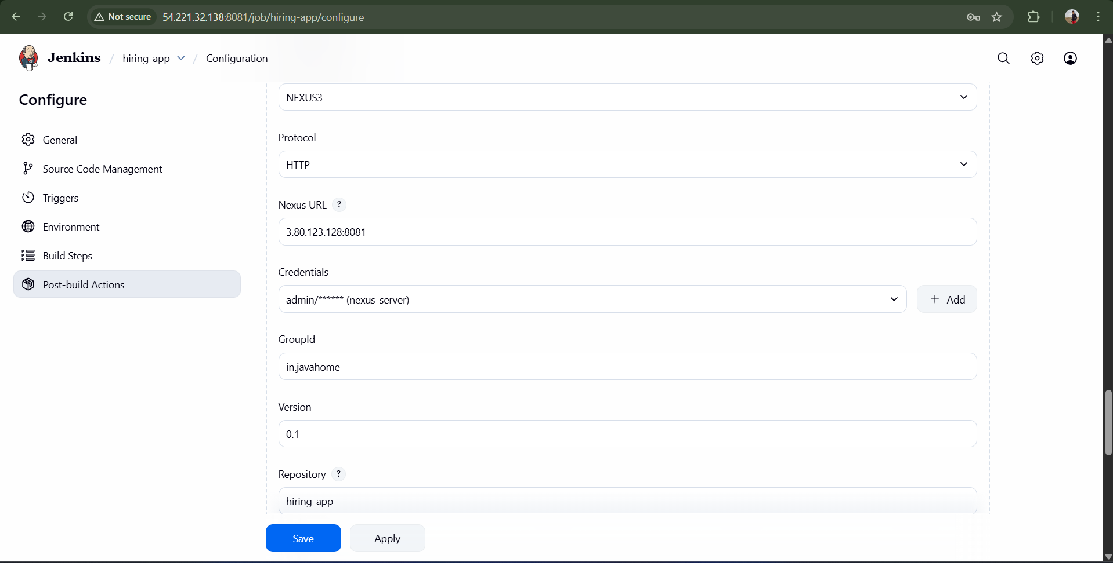
Add Artifact Details as below from pom.xml file
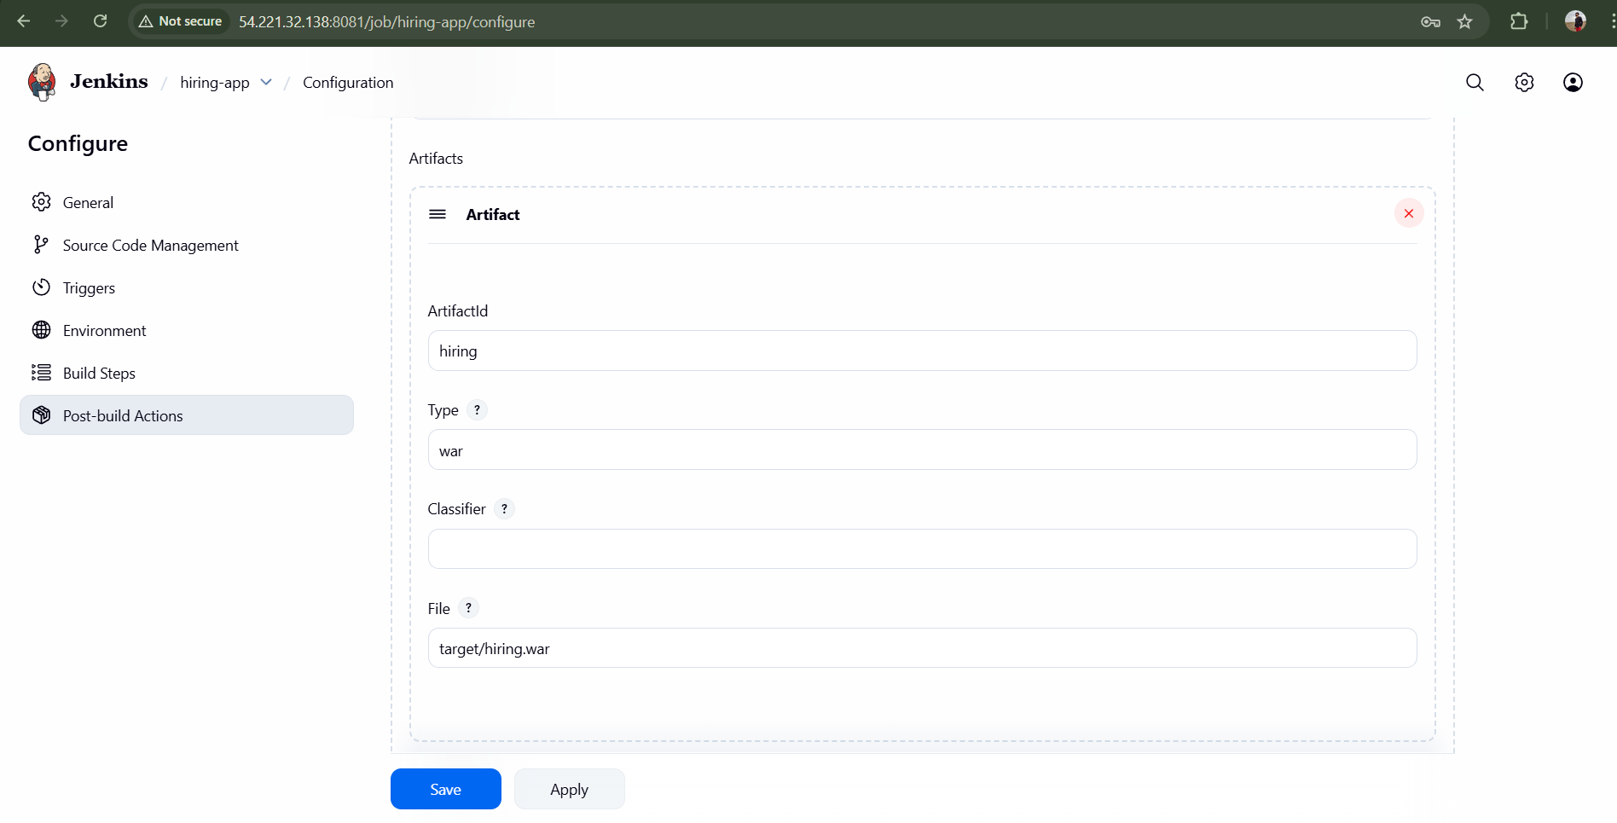
Click Save

Now Run Build
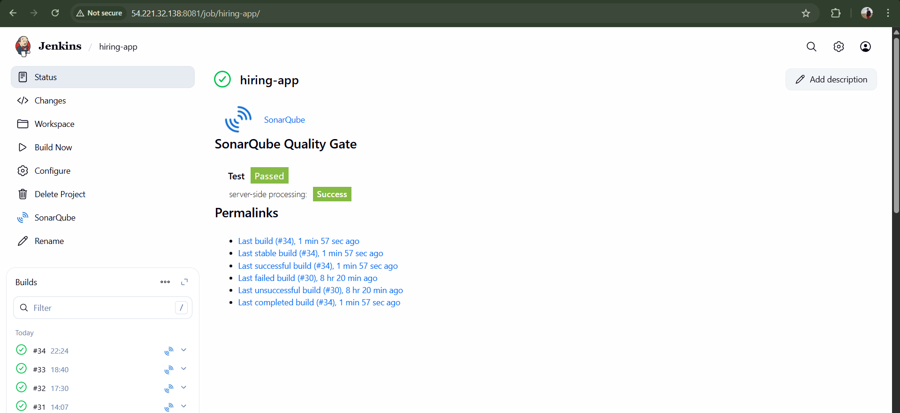
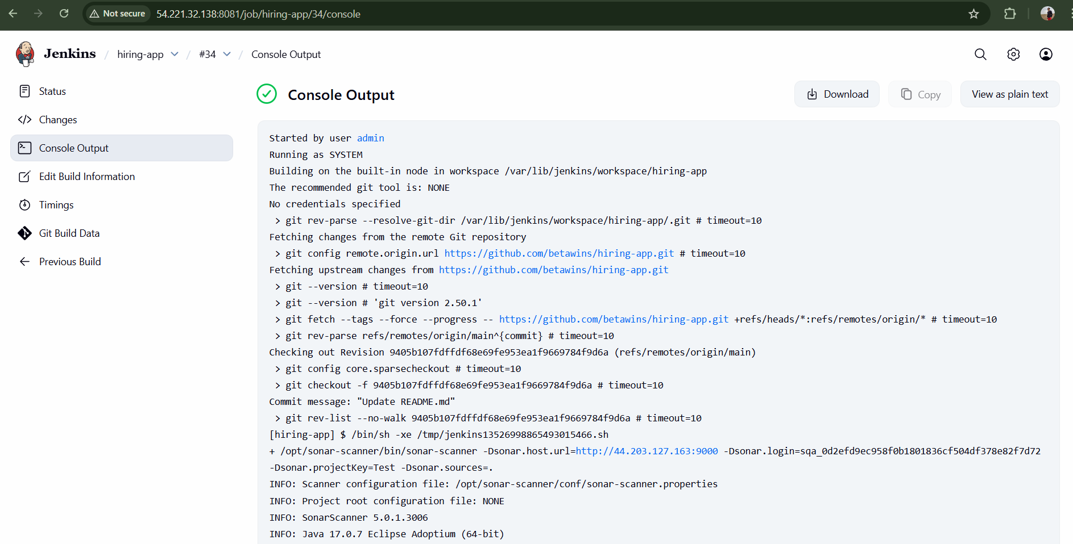
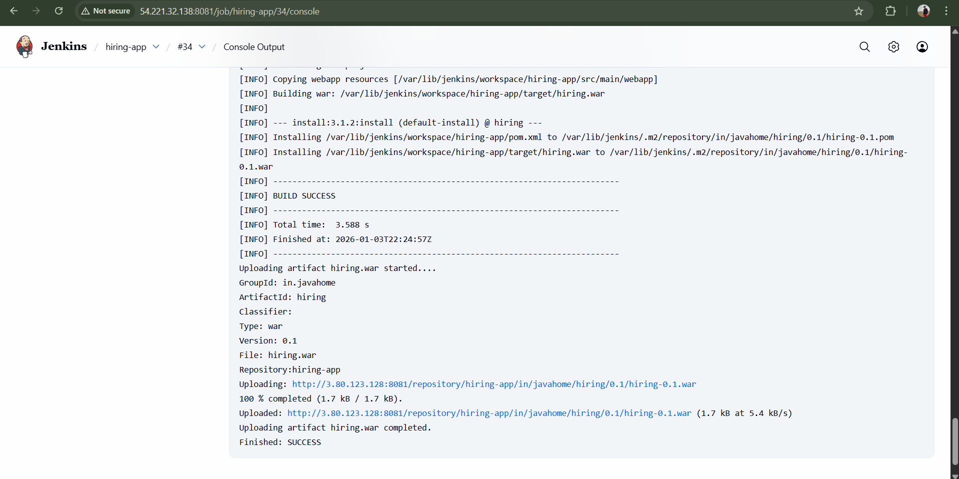
Check Nexus GUI for war file
Browse select repository <hiring-app> upload component
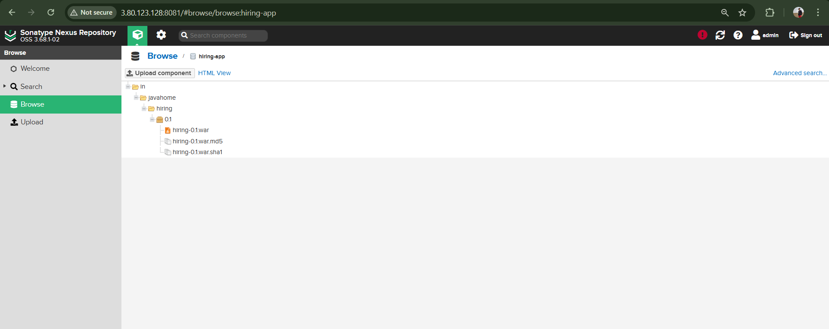

Slack Notification : To Send Notification to the Team.
Go to manage Jenkins System Slack
Added credentials with slack token created earlier and attached to slack in systems
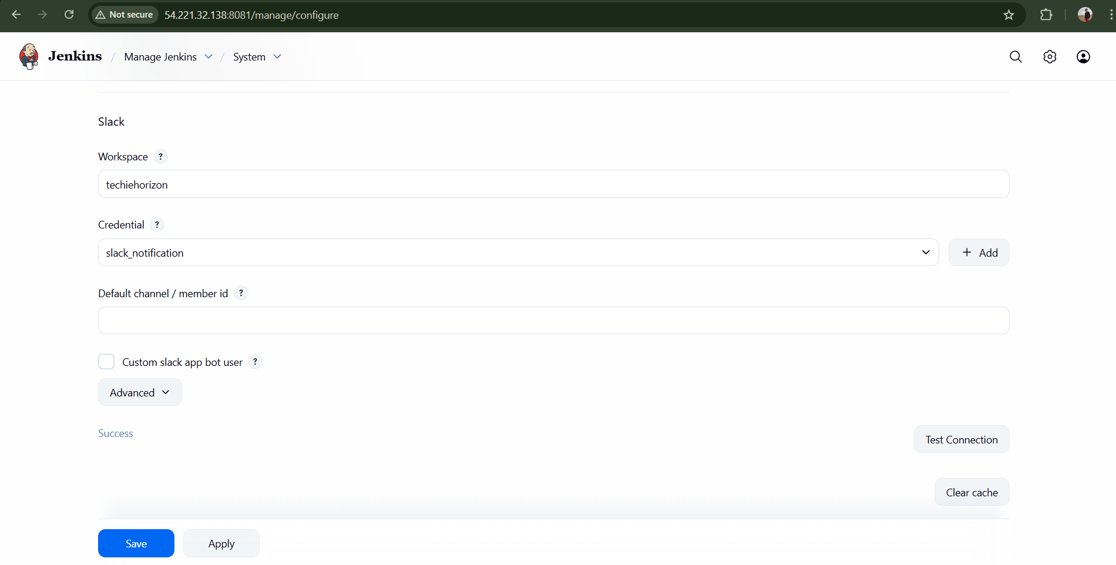
Under Post-Build Actions
Goto your job <hiring-app> Configuration select <Slack Notification>
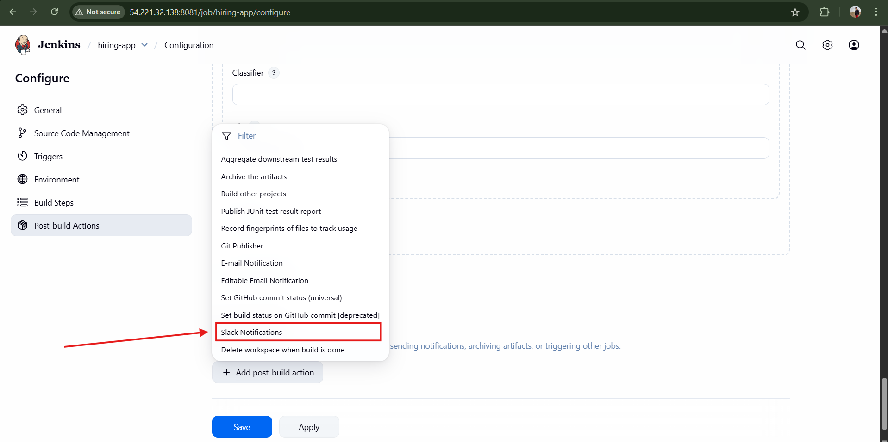
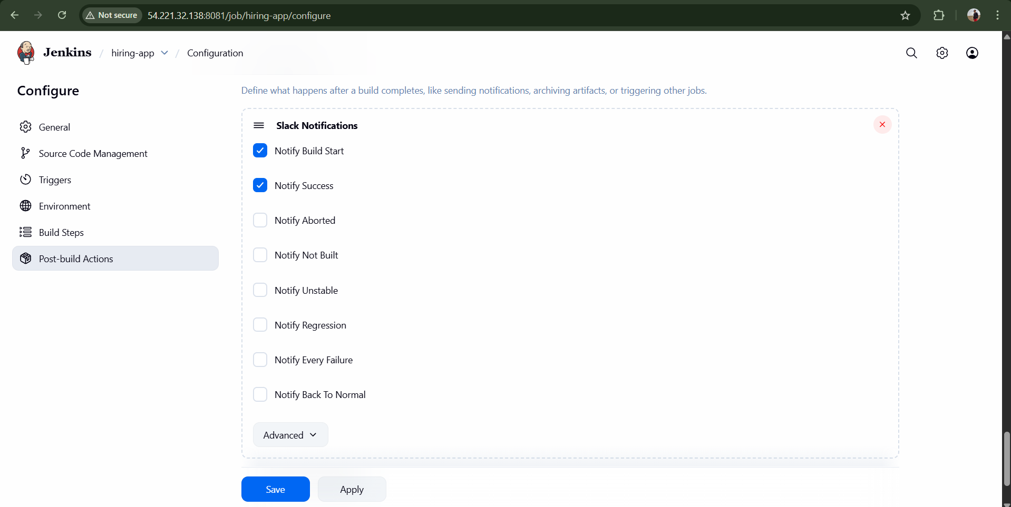
Click Save
Now Run the Build
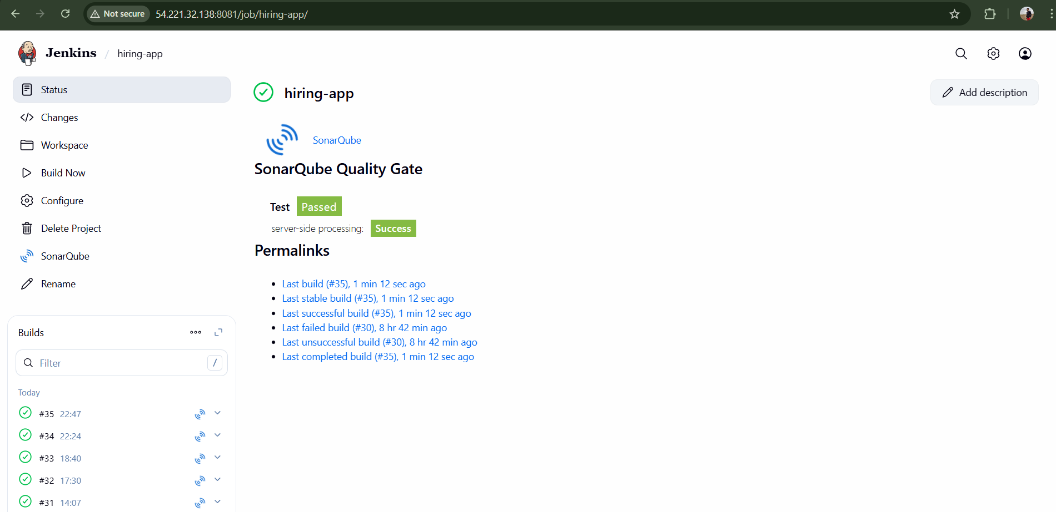
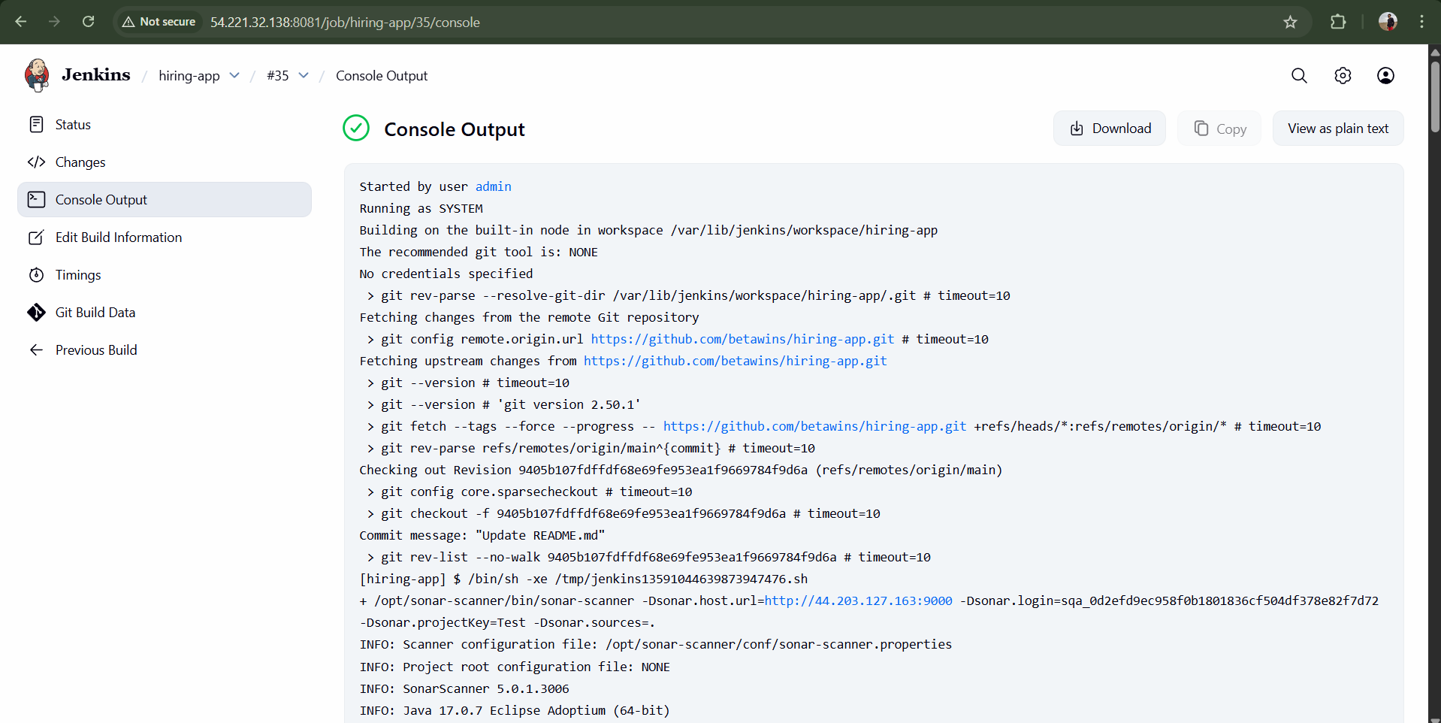
Successfully got Notification in Slack
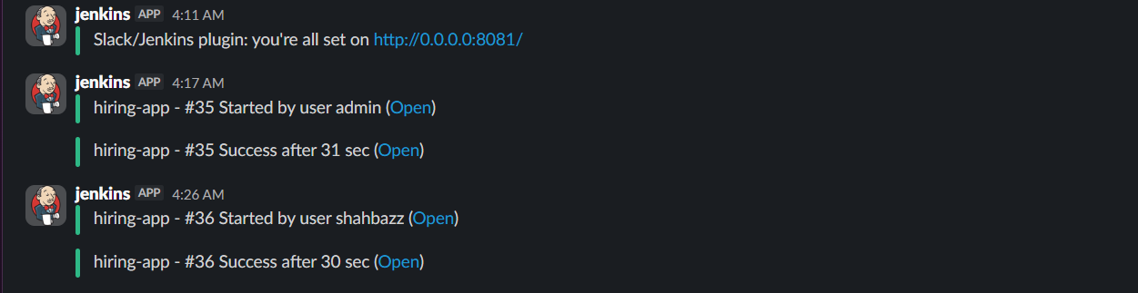

Deploy On tomcat
Goto Jenkins GUI page Manage Jenkins Available Plugins <Deploy to container>
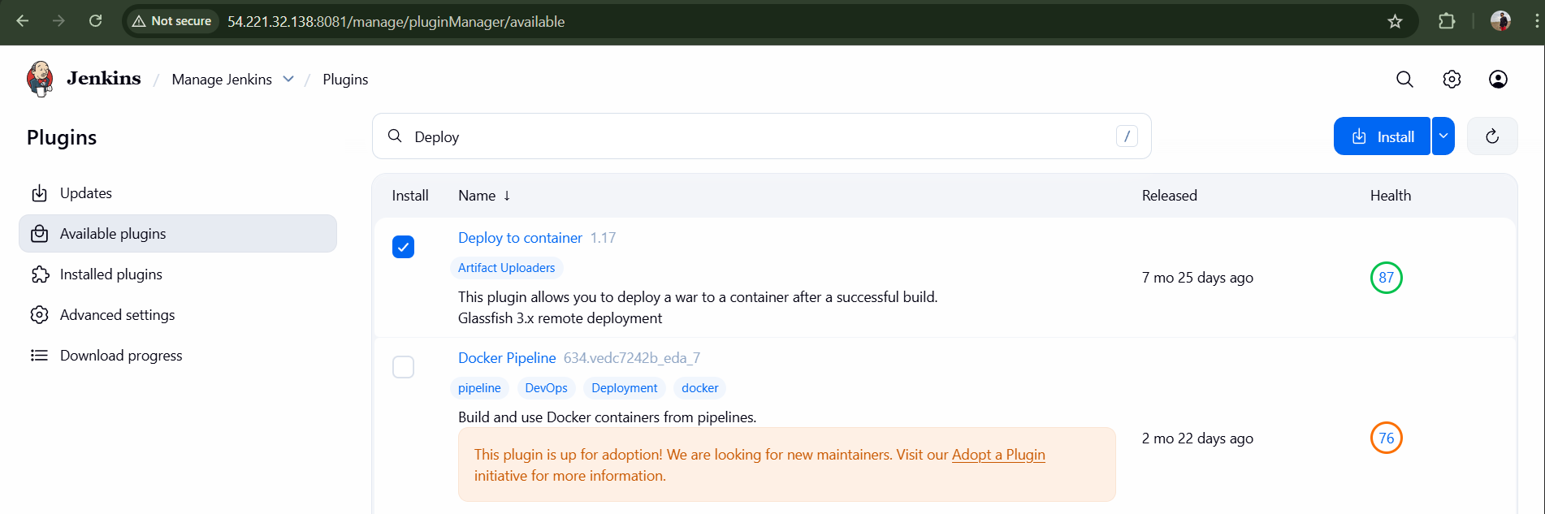
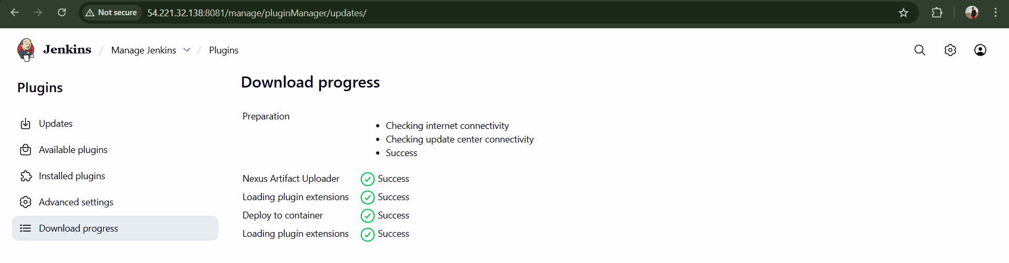
Now Launch a new ec2 instance for tomcat deployment
Tomcat-ec2 <t2.micro>
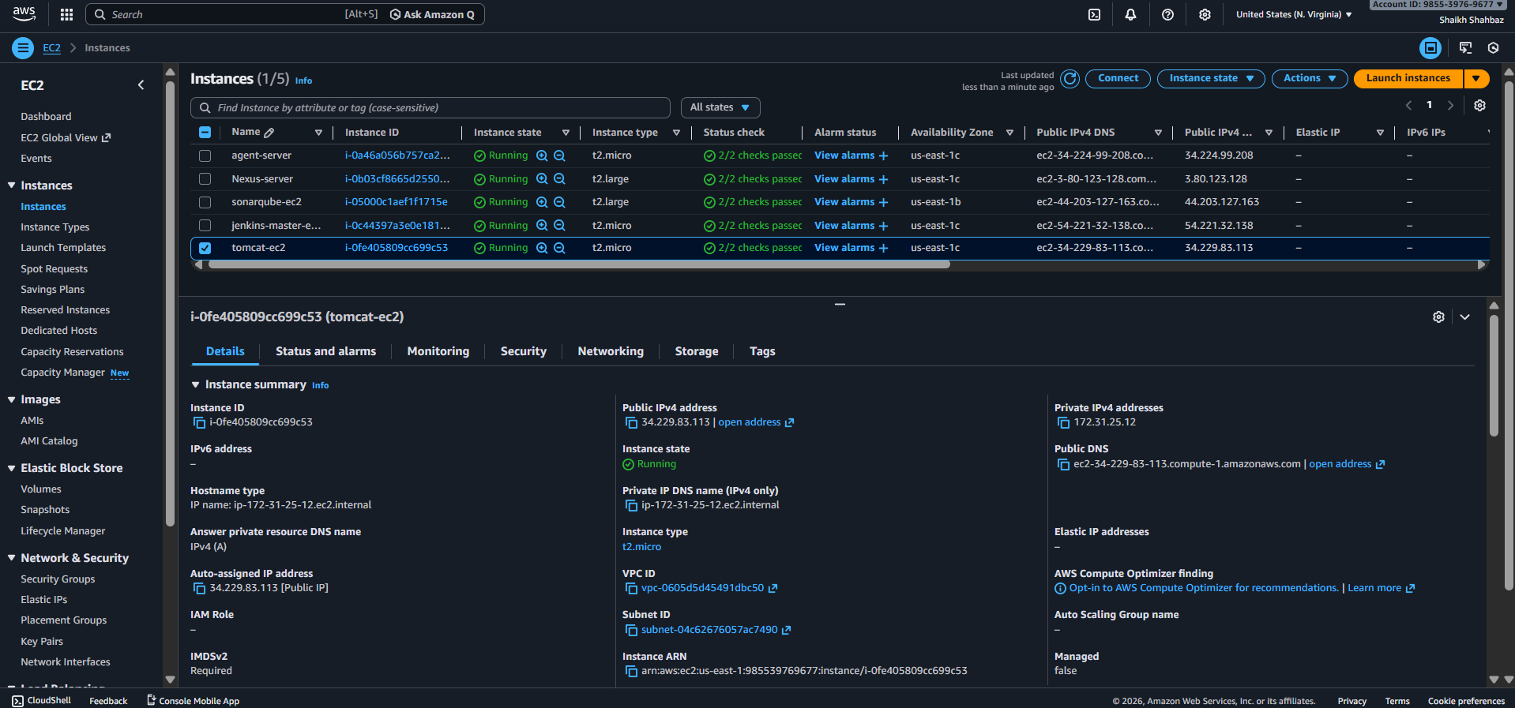
Install java and install tomcat in it and start
Install java yum install -y java-17-amazon-corretto
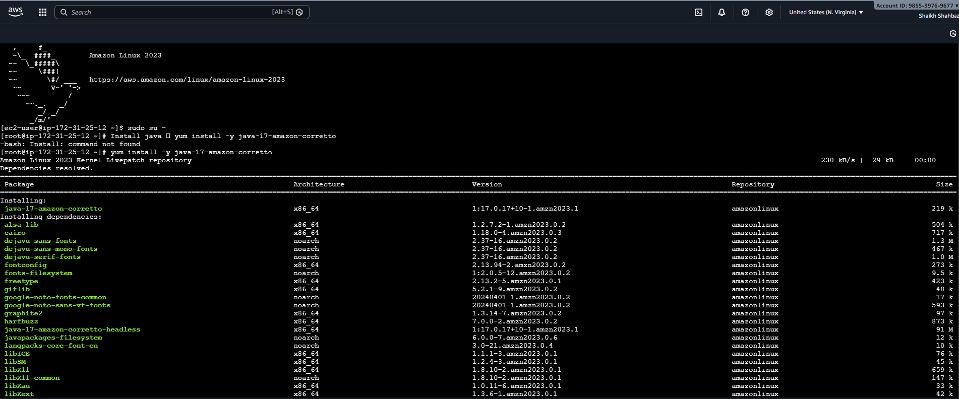
Java -version
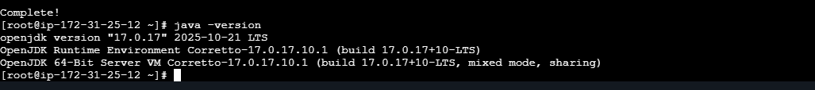
cd /opt
wget https://dlcdn.apache.org/tomcat/tomcat-9/v9.0.113/bin/apache-tomcat-9.0.113.tar.gz
tar -xvzf apache-tomcat-9.0.113.tar.gz
mv apache-tomcat-9.0.113 tomcat
cd /tomcat cd /bin
bash startup.sh
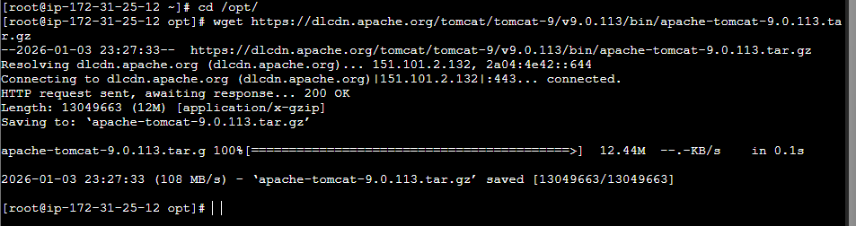
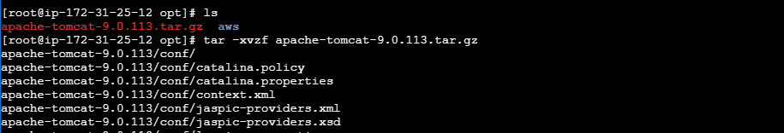
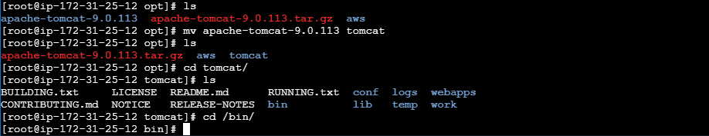
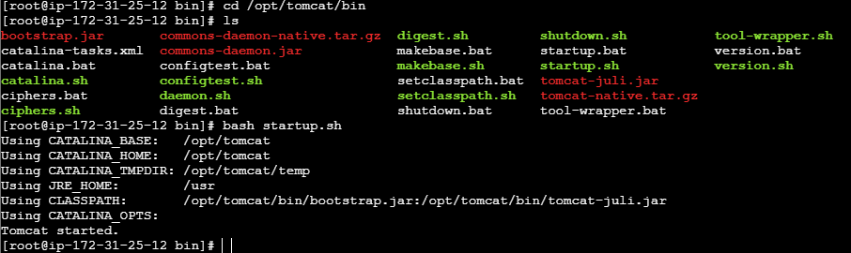
Tomcat successfully started
Check on Browser with <Public-ip>:8080
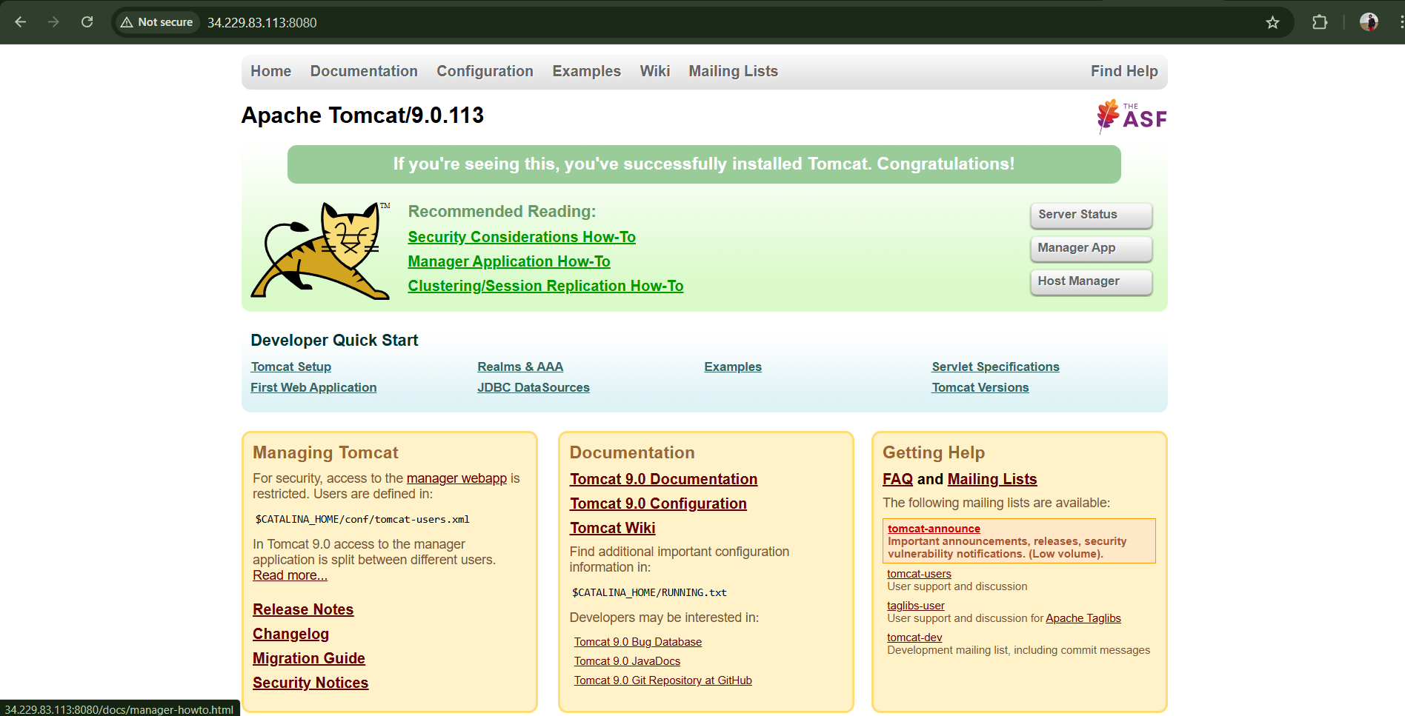
Now create user in tomcat
Tacke file webapps and edit the 4-Files <uncomment>
find / -name context.xml
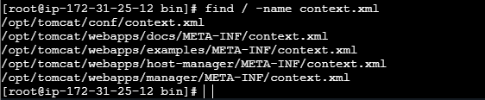
Add comment <!-- & --> to above 4-files
vi /opt/tomcat/webapps/docs/META-INF/context.xml
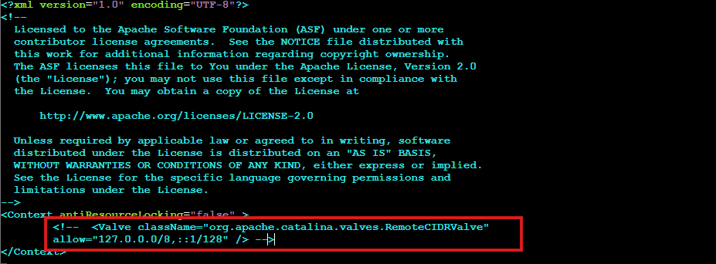
vi /opt/tomcat/webapps/examples/META-INF/context.xml
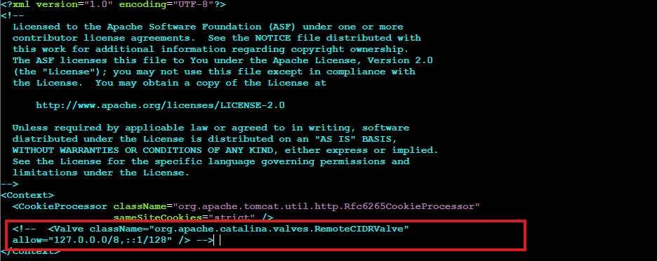
vi /opt/tomcat/webapps/host-manager/META-INF/context.xml
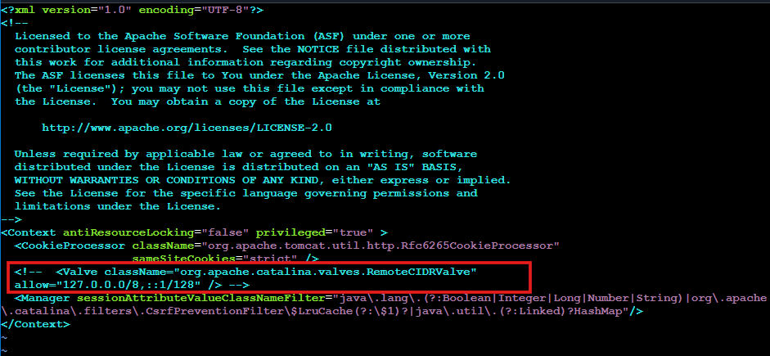
vi /opt/tomcat/webapps/manager/META-INF/context.xml
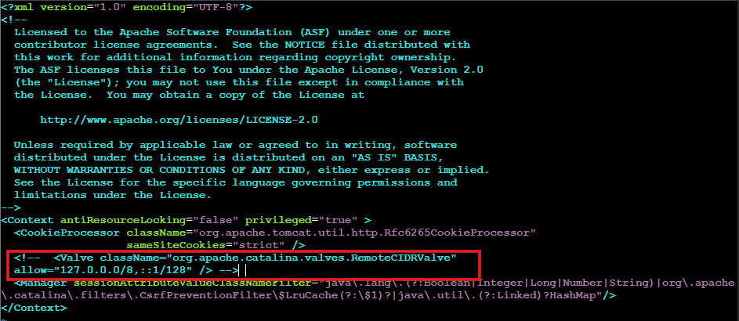
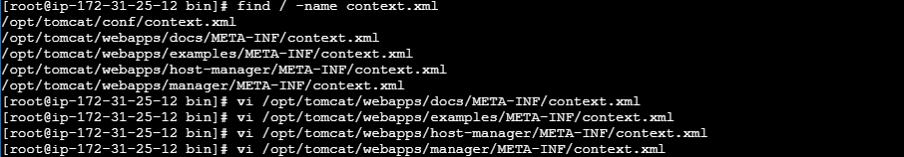
Now go to conf in xml file and add the below details to add user to tomcat <tomcat-user.xml>
cd /opt/tomcat/conf/
vi tomcat-users.xml
<role rolename="manager-gui"/>
<role rolename="manager-script"/>
<role rolename="manager-jmx"/>
<role rolename="manager-status"/>
<user username="admin" password="admin" roles="manager-gui,manager-script,managerjmx,manager-status"/>
<user username="deployer" password="deployer" roles="manager-script"/>
<user username="tomcat" password="s3cret" roles="manager-gui"/>
After adding user to tomcat we need to shutdown and then start the tomcat server
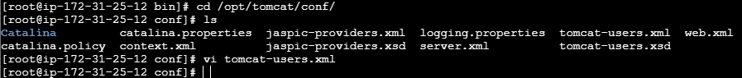
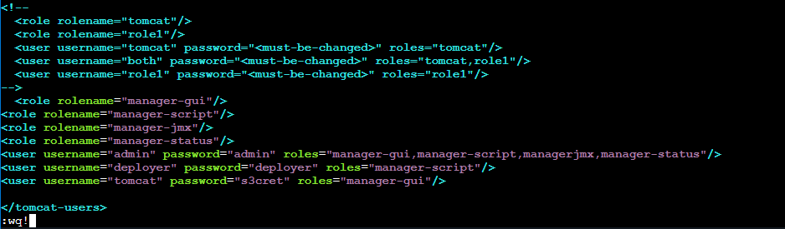
Shutdown tomcat bash shutdown.sh
Start tomcat bash startup.sh
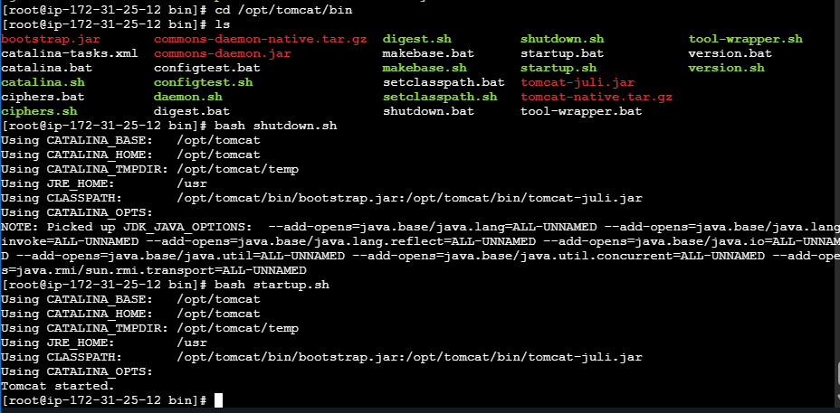
Refresh the tomcat server page then click on server status
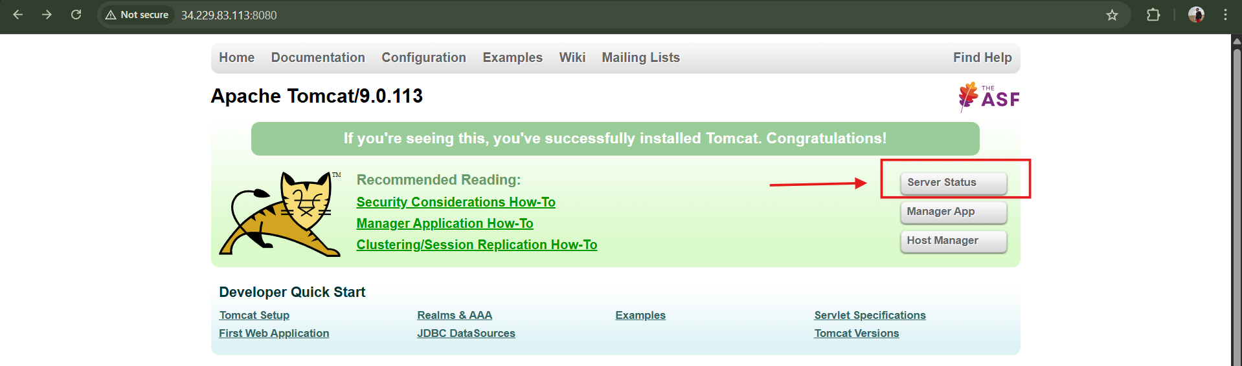
Username: deployer
Password: deployer
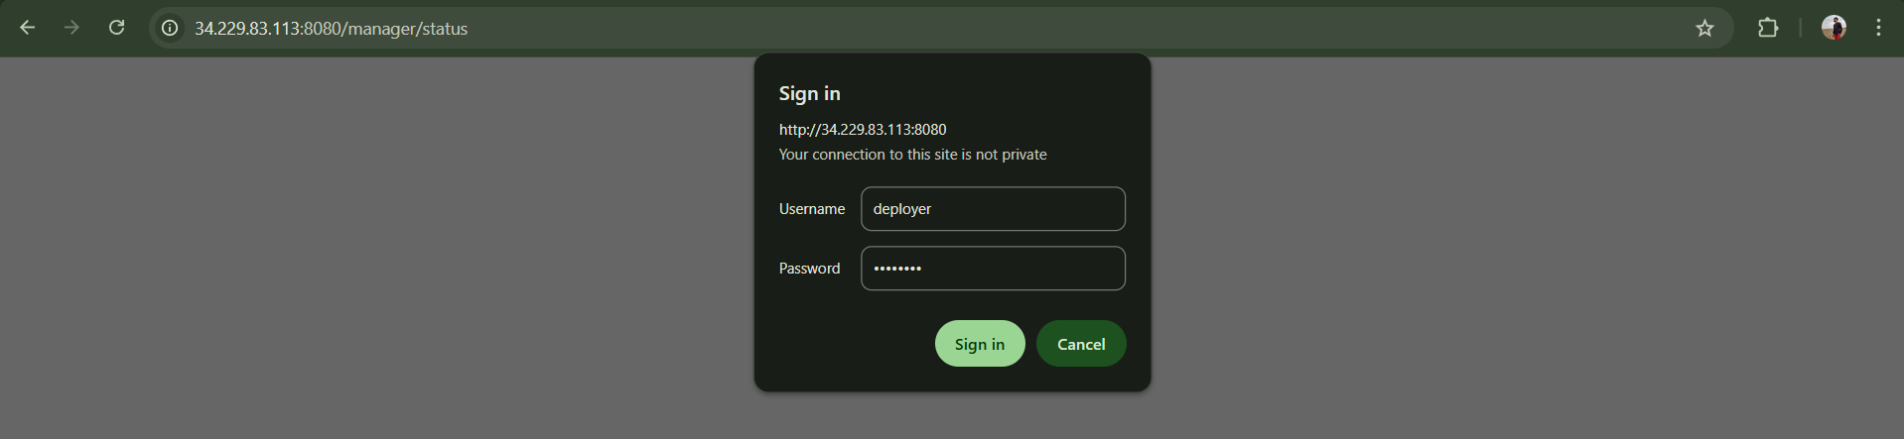
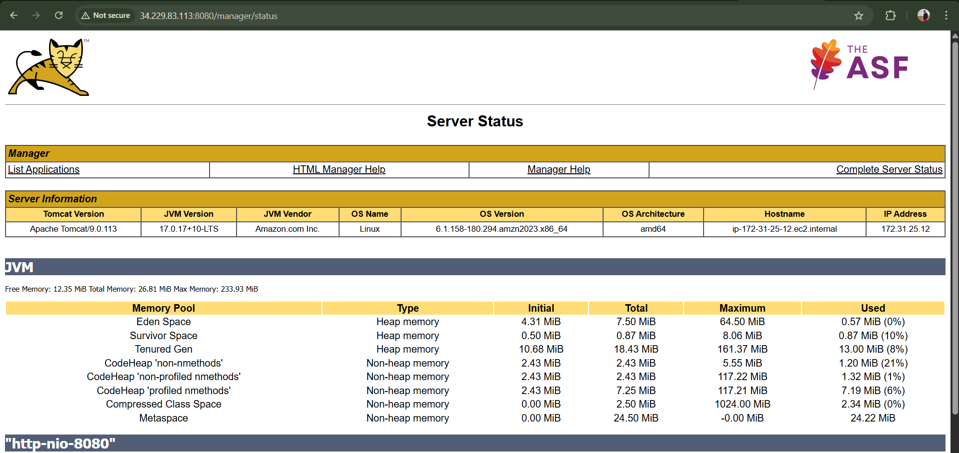
Now just go to Jenkins GUI and add these crendentials and add WAR/EAR files as **/*.war
Add the same credentials
Goto Jenkins your job <hiring-app> configuration Post-build Actions
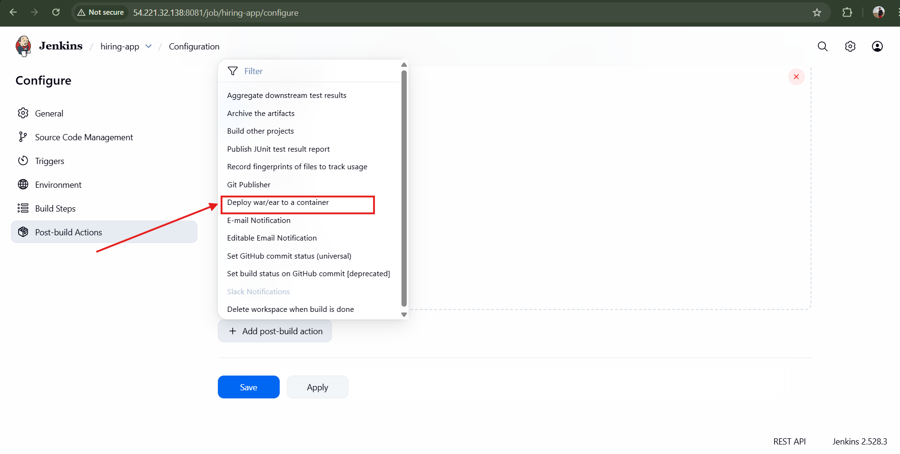
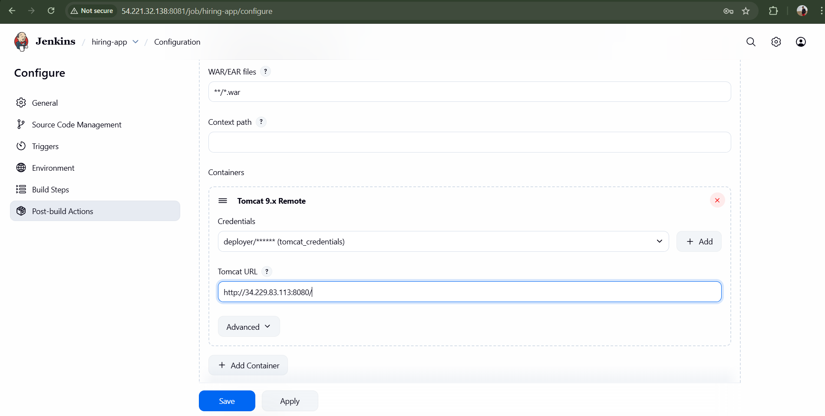
Add tomcat credentials Username: deployer Password: deployer
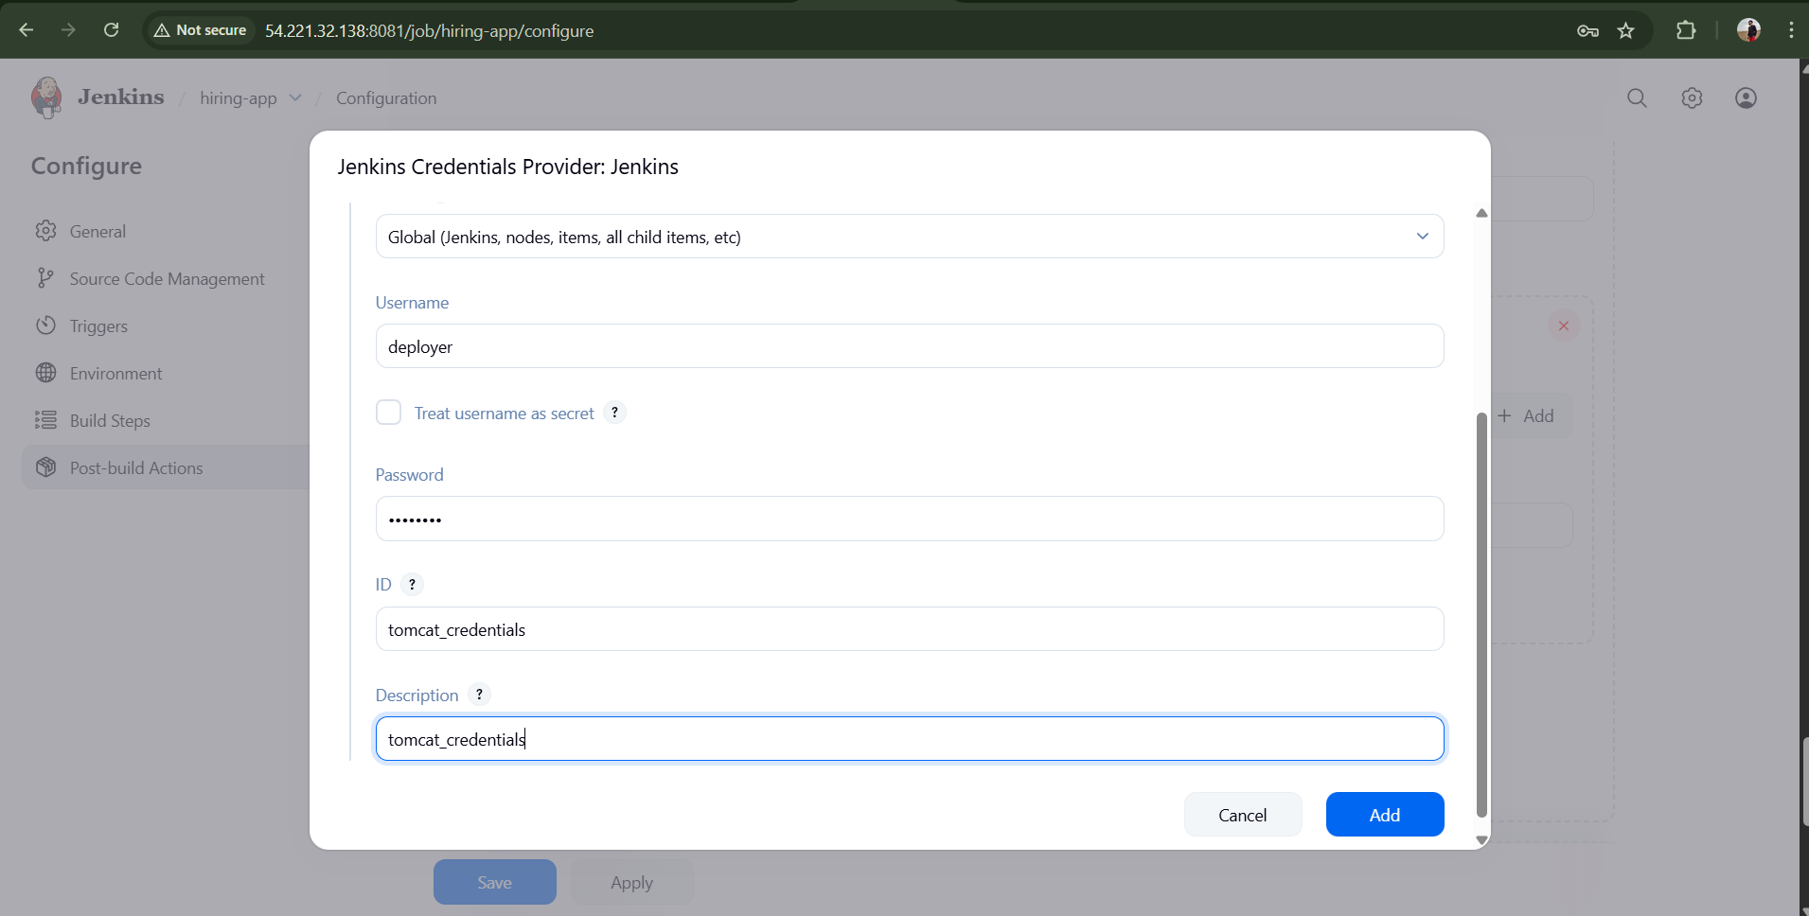
Click Save
Now Run Build for your job <hiring-app>
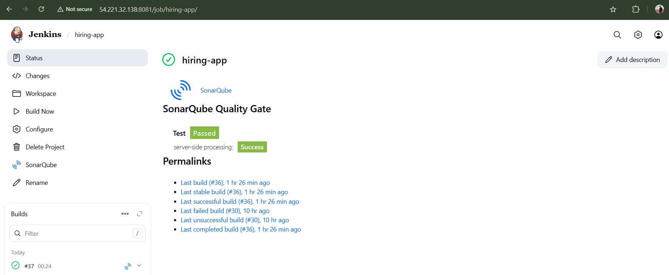
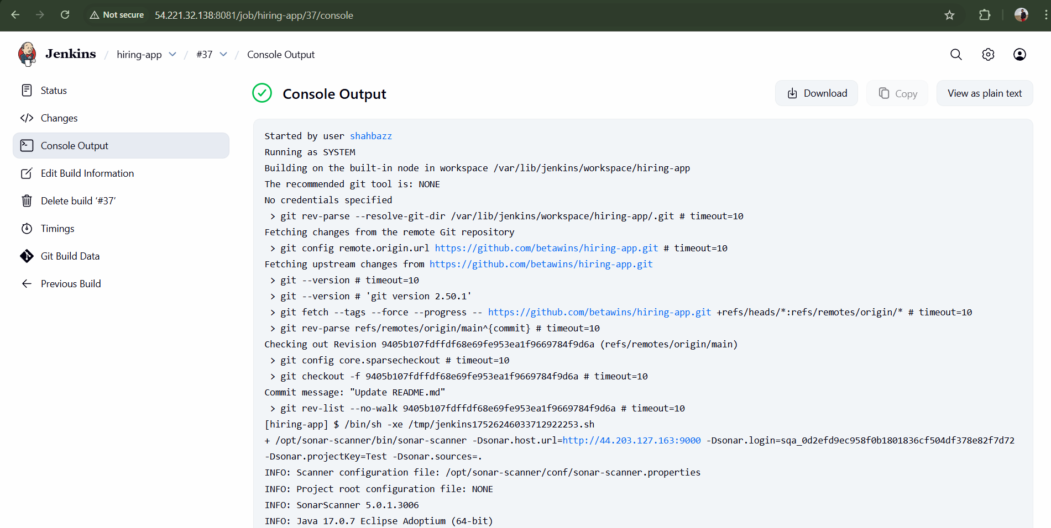
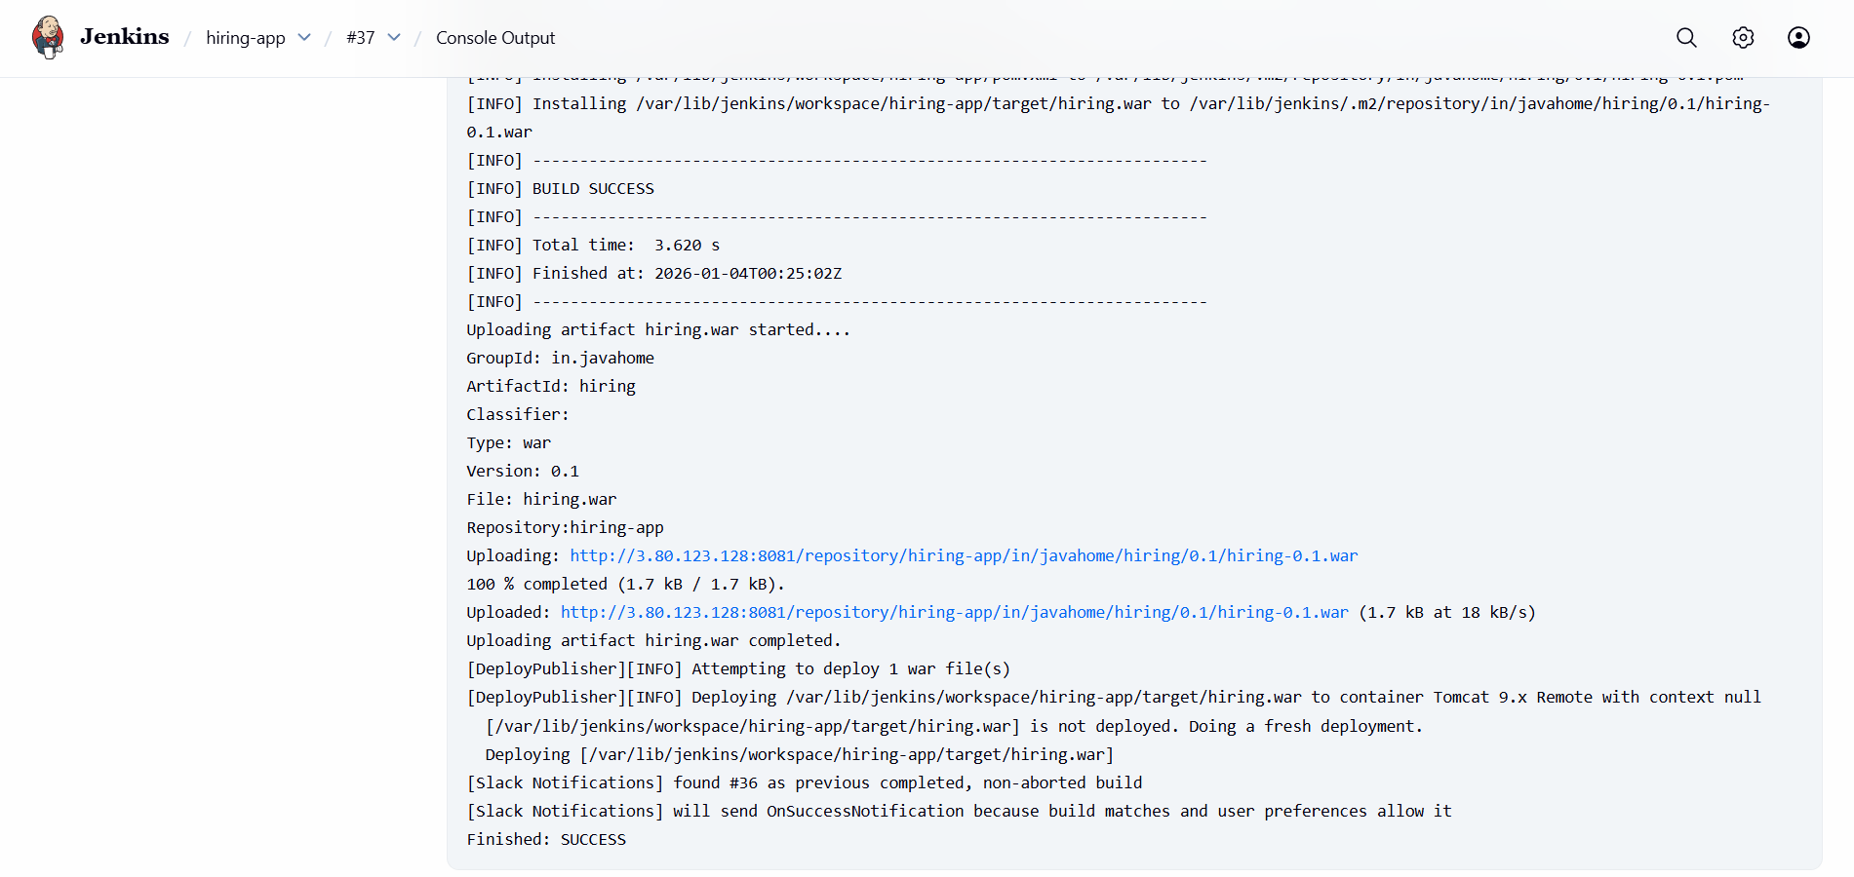
Validation: Slack Notification
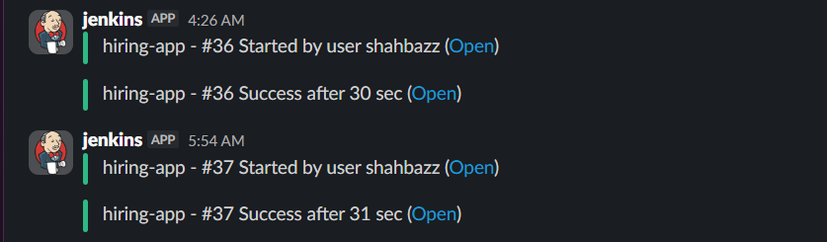
Now our deployment is successful
Now you can check in tomcat cli webapps one file is shown
cd /opt/tomcat/webapps/hiring
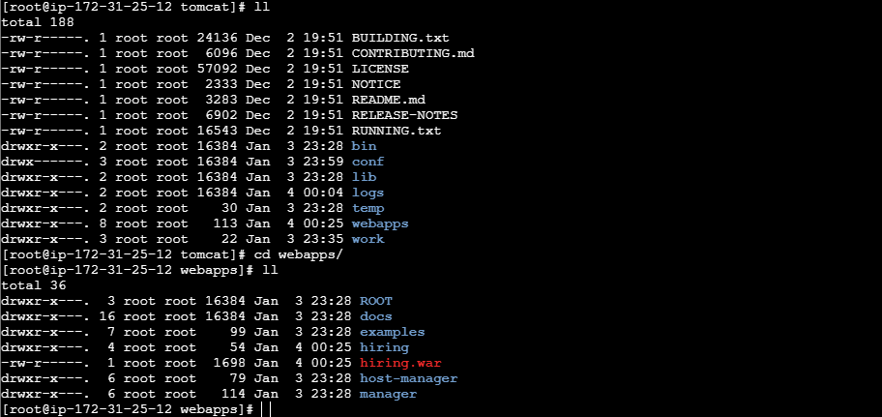

Now we are able to check in tomcat server in browser we got our application is live

Validation:http://34.229.83.113:8080/hiring/
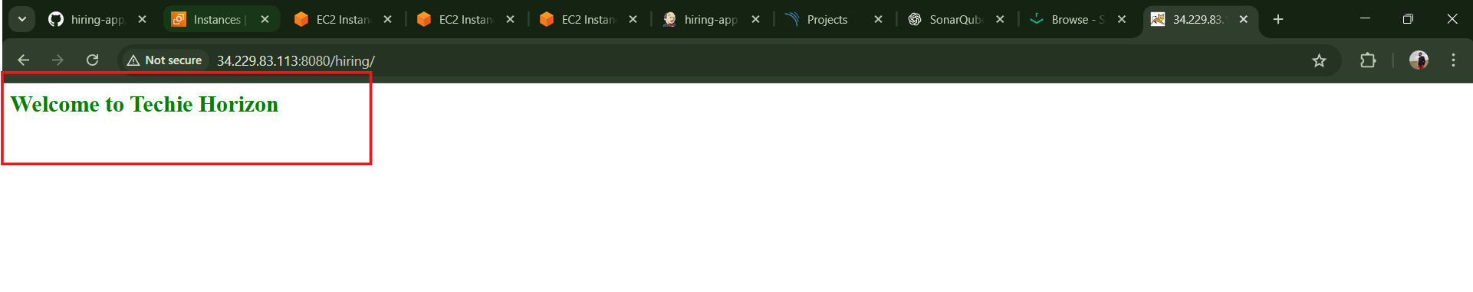
Hence we have our Tomcat server Deployment successful
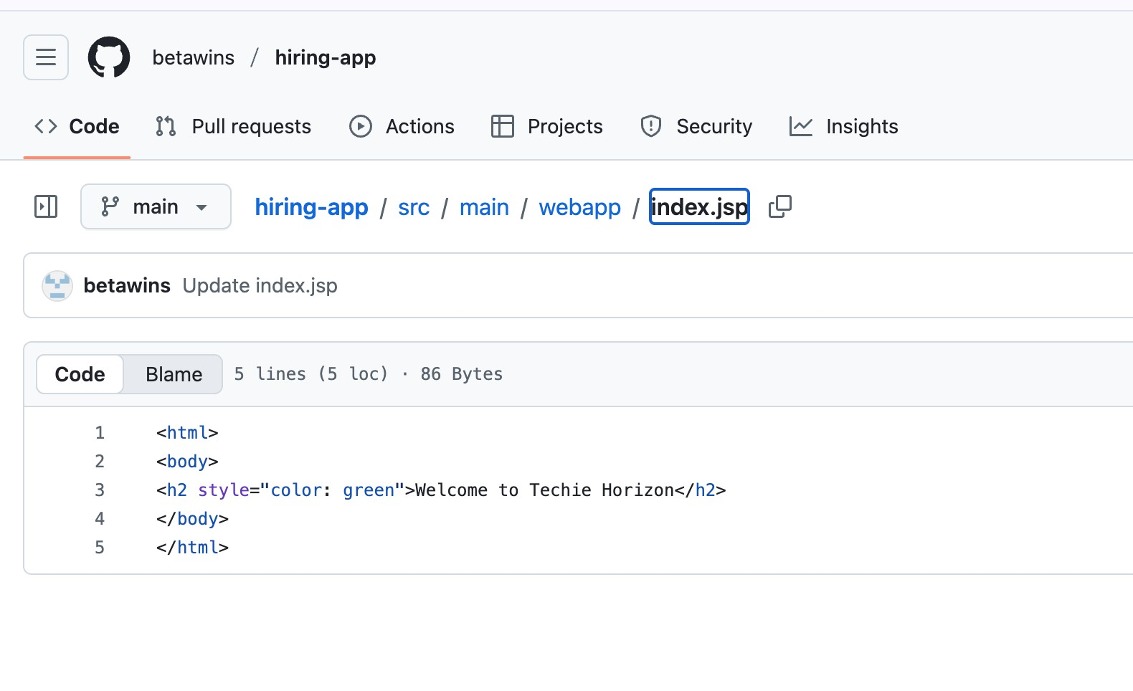
Conclusion:
Developer Push Code → GitHub → Jenkins Webhook Trigger
→ Maven Build in Jenkins
→ SonarQube Quality Analysis
→ Nexus Artifact Upload (.war)
→ Slack notification on every successful job execution
→ Jenkins Deployment Job
→ Tomcat Server Running Latest App

